FORWARD
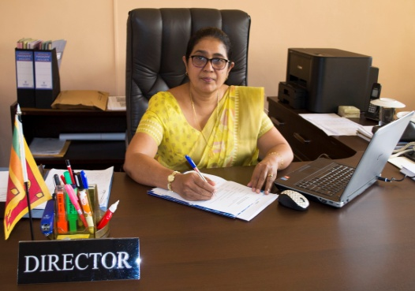
I am pleased to present the Strategic Plan 2019 - 2023 for Institute of Indigenous Medicine (IIM), University of Colombo. The Strategic Plan will also guide to strengthen learning, teaching, and research of undergraduate students and the academic staff. Further we are dedicated to provide high-quality service to the undergraduate students, academic staff, administrative staff, and administrative support staff of the institute. The strategic plan also helps to identify our Strengths, Weaknesses, Opportunities, and Threats. The results of the SWOT analysis were used to prepare the Strategic Plan for the years 2019 to 2023.
At present, Indigenous Medicine has become indispensable because of its unique approach and IIM remains one of the country’s traditional health care systems in the field of Medical education by maintaining high standards and values. IIM provides a brilliant opportunity for our undergraduate students who enter the university to expand the knowledge and skills on indigenous medicine with hands on experience on Ayurveda system of medicine or Unani system of medicine. My prime objective is to establish the State-of-the-Art higher educational Institute in Ayurveda, Unani and traditional systems of medicine through conducting teaching and research in Sri Lanka. The IIM is committed to excellence in teaching and research in Ayurveda, Unani and Indigenous systems of medicine to reinforce the recognition of Indigenous Medicine, services related to Indigenous Medicine and public outreach globally. It is very important to know that once the degree program is completed successfully, students are given an exposure for a highly diverse and nourishing environment with clinically based study programs as top-priority. The activities of the IIM are empowered through the skills and creativity of the academic staff members who have completed their postgraduate degrees in multi-disciplinary areas related to Indigenous Medicine. They offer quality services in teaching and research activities of the institutes. The research activities in Ayurveda and Unani systems of Medicine are been performed using new advances in science and technology to obtain global recognition for all the specialized areas in Indigenous Medicine. The high quality academic staff members who are committed to disseminate knowledge in all the areas of Ayurveda and Unani systems of Medicine are available to achieve highly stimulating clinical based teaching and research environment in the institute. At present 93 academic staff members from specialized fields of Ayurveda and Unani are available to conduct teaching and research in the institute. I have been witnessing the efforts of the staff members of the IIM towards the improvement of the health and overall wellness locally and within the international community. Our institute is committed to provide evidence-based quality education of Indigenous Medicine and we are proud to integrate the use of advanced technology to uplift the quality and standards of the academic life at IIM. Our institute is affiliated with the Ayurveda Teaching hospital Colombo to provide clinical based healthcare systems in a holistic way and the teaching hospital is armed with consultants, expert physicians, surgeons and supporting staff, competent facilities like IPD services with around 15 wards, IPD services with Kaya Chikitsa Unit, Ayurveda Surgery unit, Ayurveda Gynecology and Pediatric units, and special OPD services with traditional medical units such as eye treatments, traditional orthopedic treatments and snake bite treatments, Yoga unit, and Korean Acupuncture and Physiotherapy unit. Ultimate goal of our institute is to produce knowledgeable skilled doctors in Ayurveda or Unani systems of Medicine.

Senior Prof. PA Paranagama
Director / IIM
TABLE OF CONTENTS

Page
Forward 01
Introduction 03
Historical Background 05
The Institute Today 08
International Collaboration of the Institute 35
SWOT analysis 36
Vision and Mission Statements 41
Our Values 42
The Role of the Institute 43
Corporate Goals 44
Goals and Objective of the Institute 45
Key Performance Indicators 57
Corporate Structure 64

INTRODUCTION

The Institute of Indigenous Medicine
The Institute of Indigenous Medicine (IIM) is the premier higher educational institute in Sri Lanka which creates medical graduates in Indigenous Medical Field. The institute was first started as the collage of Ayurveda and subsequently upgraded and affiliated to the University of Colombo in the year 1977 as the Institute of Indigenous Medicine. The IIM has located in the heart of the busy capital city of Colombo. At present, it produces both Unani and Ayurveda medical professionals to meet the challenging needs of primary health care, general health care problems, health promotions, and disease prevention according to the indigenous medical system. The institute admits G.C.E. (A/L) students in Biological Science stream who conform to the criteria recommended by the University Grants Commission for admission to the university.
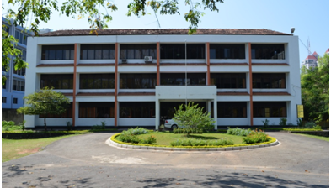
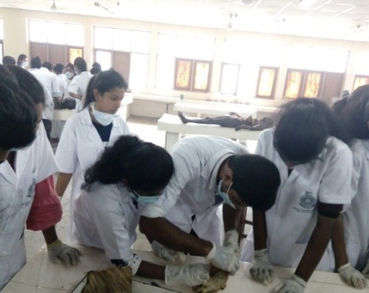
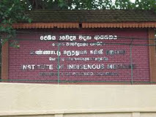
Thus, the selected undergraduates are offered two degree programs by IIM under two major sections namely Ayurveda section (BAMS degree program) and Unani section (BUMS degree program).
• The BAMS program (Bachelor of Ayurveda Medicine and Surgery) spreads over6 years of time duration, including 5 years of academic studies followed by 01 year internship.
• The BUMS program (Bachelor of Unani Medicine and Surgery) spreads over 6 years of time duration, including 5 years of academic studies followed by 01 year internship.
The Ayurveda section comprises of 8 academic departments with 54 academic staff members and Unani section comprise of 7 academic departments with 29 academic staff members. Majority of the academic staff members have obtained their postgraduate degrees in relevant field from local as well as foreign universities (India, China). Thus, the degree programs of IIM have been designed to produce Ayurveda/Unani practitioners who are capable of effectively utilizing indigenous medical system as well as modern diagnostic technique/methods to treat patients effectively. The clinical component of the programs is conducted with the collaboration of National Ayurveda Teaching Hospital at Borella, which is closer by to the Institute.
In addition to the undergraduate programs, the Institute offers short term Certificate Courses in Ayurveda relevant fields.
To strengthen the involvement in research studies, the Institute has established the Ethics Review Committee and Research management Committee. The IIM has provided adequate hostel facilities and other infrastructure facilities to the students and new proposals are being prepared to increase facilities in hostels. The employability of graduates of IIM is at satisfactory level as they can involve in both government and private sector institutes. The Institute of Indigenous Medicine has close relationships with Gampaha Wickramarachchi Ayurveda Institute and Ministry of Health, Nutrition and Indigenous Medicine. Further, IIM has established strong collaboration with foreign institutes in India, Japan, and China to strengthen the skills of academic staff as well as undergraduates. The Institute organize a research symposia annually (ICAUST/International Conference on Ayurveda, Unani, Siddha and Traditional Medicine) to enhance the research collaboration with international research institutes to provide a platform for academic staff members and undergraduate students to promote research.

HISTORICAL BACKGROUND

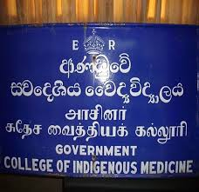

At the end of the 19th century, the Ceylon (a British colony), had a system of indigenous medicine, but without college for providing indigenous medical education. The three associations / bodies which were establishing during the period had started the preliminary work for preservation of traditional status of those who engaged in practicing oriental medical system. These associations were "The Sinhalese Medical Association" (1891), "Sri Lanka Vaidya Maha Mandalaya" (1901) and "Sri Lanka Samajaya Prathishakthikarana Sangamaya"(1915).Eminent personalities such as, Sri Solaman R Dias Bandaranaike, FR Senanayaka, K Balasingham, Donald Ubhayasekera and Ananda Kumaraswamy the great patriots were the pioneer in creating the fund for this purpose.

In 1926, for the first time, a committee that looked into indigenous medicine system proposed that a collage should be established with adjoining teaching hospital, to provide training for those who were keen to pursue this system of medicine. Then the state Council (Rajya Manthrana Sabawa) appointed an advisory council titled "Ayurveda Sammelana Sabha" in 1928 keeping Dr K Balasingham as its chairperson. Based on this Committee Recommendation, an institute named "Swadeshiya Vaidya Vidyalaya" (Indigenous Medicine College) was established on 10th June 1929, and it was inaugurated by the governor General of Ceylon, Sri Herbert James Stanley, at the Bauer building situated at cotta road, Borella. Dr. ANN Panikkar from India who had western medical qualification and who possessed a sound training in Ayurveda Science was brought down to the newly established college by the government as its first principle. Similarly, Dr HM Jaffer and Dr. H Ahamed were also brought down from India to develop Unani System Medicine.
Another milestone in the field of indigenous medical system was the enactment of Indigenous medical ordinance no. 17 of 1941. Hon. SWRD Bandaranayake as the minister of health and the chairperson of the indigenous medical Advisory Council has brought the legislation to uplift the quality of teaching of the college with a national standard. In 1961, the Ayurveda Act No. 31 of 1961 was enacted by repealing the Indigenous Medical Ordinance No. 17 of 1941 and the College was renamed as the Government College of Indigenous Medicine and came under the management of the College and Hospital Board. This step was taken to uphold the quality of Ayurveda healthcare delivery and the systems of education in Ayurveda, Unani, and Siddha. Four statutory boards namely, Ayurveda Medical council, the college and hospital board Ayurveda Research and Ayurveda Drug Formulary Committee were also created.

In 1963, the name & qualification of Diploma in Indigenous Medicine &Surgery (DIMS), was changed to that of the Diploma in Ayurveda Medicine and Surgery (DAMS) under the new Ayurveda act.

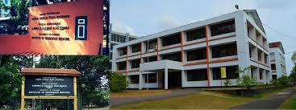

In 1977, the College of Indigenous Medicine was renamed as the Institute of Indigenous Medicine and affiliated to the University of Colombo under the University Act No. 1 of 1972. This was done by the Institute of Ayurveda Statute No. 1 of 1977, published in the Government Gazette Extraordinary bearing number 258 of March 30, 1977. The objective of this step was to produce the qualified medical practitioners in the field of Ayurveda, Unani and Siddha medical systems. The Institute of Indigenous Medicine Ordinance No. 7 of 1979 published in the Government Gazette Extraordinary bearing No. 67/14 dated December 21, 1979 under the Universities Act No. 16 of 1978 andwith this enactment, the Siddha section was separated and affiliated to the University of Jaffna.

The institute has made many changes to the syllabus with approval of the senate of the university. One such major revision was in 1982 where the assistance of specialists in various sections in Ayurveda, Siddha, and Unani for which expert advices obtained from Prof. PNV Kuruppu, advisor on Ayurveda of World Health Organization.

Currently the institute has the strength of well skill postgraduate qualified academic staff in the relevant field & 23 of different subject areas are thought during 5 academic years under their teaching responsibilities. The syllabi consist study material on Ayurveda/ Unani and other science related field to contribute a competent Indigenous Medical graduate. Each academic year consists of 30 weeks teaching during three times, with two mid-term vacations. Annual examination is heldat the end of each academic year. Each examination consists of written, viva-voce and practical /clinical components. (OSPE & OSCE)

With the establishment of the Institute in 1977, imparting instructions for the two degree programmes, i.e. Degree of bachelor Of Ayurveda Medicine and Surgery (BAMS) and the Degree of bachelor of Unani Medicine and Surgery (BUMS) commenced under the two sections of the Institute and the degrees were conferred for the first time at the convocation of the University Of Colombo held on 26.10.1992.

In addition to undergraduates' education, the institute conducts two postgraduate degree programmes such as postgraduate diploma in Ayurveda/Unani Medicine and M. Phill degree in Ayurveda/Unani. The postgraduate section is under the supervision of the additional director which was appointed from the senior teachers of the institute. All postgraduate programmes are done under the purview of the Higher Degrees Committee of the Institute.

Several steps have been taken for curriculum reforms and syllabus revision with the incorporation of more applied aspects in Indigenous of pioneer in providing human resources for the delivery of Indigenous System Medicine in the country.

THE INSTITUTE TODAY

The institute consists of two departments; Department of Ayurveda and Department of Unani. Each department has eight units as given below.
Academic units of Ayurveda | Academic units of Unani
- Moulika Siddhantha | - Kulliyath
- Allied Science
3. Dravyaguna Vignana | - Ilmul Advia
4. Swasthavritta | - Tahaffuziwa Samaji Tib
5. Kaya Chikitsa | - Moalijat
6. Shalya Shalakya | - Ilmul Jarahat
7. Prasuthi Thantra Kaumarabhritya | - Amraz e Niswan, Qabalat va Atfal
8. Desheeya Chikitsa | - Desheeya Ilaj

Departments of Study (Ayurveda Section)

Department of Study in Ayurveda

The earliest references of Ayurveda medicine in Sri Lanka are associated with a great physician; Ravana a king of Sri Lanka dating back to the prehistoric times. Traditionally, it is believed that Ravana of Ramayana fame was well versed in Ayurveda medicine. Ramayana mentions that he represented Sri Lanka at a medical symposium at the base of Himalaya in India during his era. There were four tribes, Yaksha, Raksha, Naga, and Vaddas in Sri Lanka at the given time. According to Historiography in Sri Lanka King Ravana was the author of the following medicine books of Ayurveda. Arkaprakasya, Nadivignanaya, Kumarathanthraya and Udishathanthraya.

Sri Lanka has a rich assortment of medicinal plants of which some are endemic to the country. The majority of the plants used are the same as those used in India. Dolukanda and Rumassala are believed to be fragments of a part of Himalayas that were carried over to Sri Lanka by the mythical monkey King Hanuman of King Rama. Evidence unearthed from prehistoric burial sites speaks of the ancient practices of Ayurveda across Anuradhapura, Polonnaruwa, Madirigiriya and Pomparrippu.

The only structural remains of ancient hospitals that have so far come to light are of those established in the old monasteries of Mihintale, Madirigiriya and Alahana in Polonnaruwa. The identity of those hospitals has been established with the help of inscriptions and discovery of medicine and other equipment. As a reference to the Mahavansa and Chulavansa many of the ancient kings have dedicated their services to the development of Ayurveda medicine in Sri Lanka. Examples of such practices are King Pandukabhaya (4th Century BC), King Sena (851-885 AD), King Buddhadasa (362-409 AD), King Datusena (460-478 AD) etc. As such ancient Ayurveda evidence shows that Sri Lanka has inherited a glorious history of indigenous medicine in the country.

But it faced setbacks during the late part of the 16th century due to foreign invasions. Afterwards Ayurveda developed on an own independent process. It is practiced annually as a traditional process. (Parental inheritance) Ex: EsVedakama (Ophthalmology) GediVana (Treatment of boils and carbuncle), Sarpavisha (Toxiology), Pissubalu (Hydrophobia), VidumPillissum (Burns), KadumBidum (Fractures and Dislocation).
At Present There are about 16,800 registered Ayurvedic medical officers of whom more than 5000 are academically and institutionally qualified to serve the country and nation.

Head of the department of study in Ayurveda

Dr. (Mrs.) KC Perera
Senior Lecturer Grade I
DAMS (Hon) (Colombo), MD Ay (BHU, India), PG. Dip in Statistics (Sri Jayawardenepura)
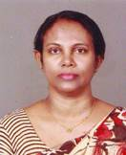

Academic Unit of Moulika Siddhantha

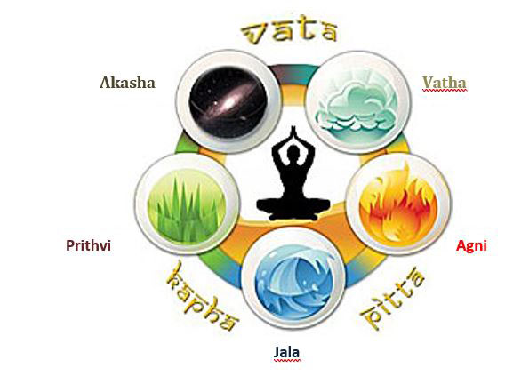
The College of Indigenous Medicine was established in 1929. It became a part of the University of Colombo adopting its current name, Institute of Indigenous Medicine (IIM) in 1977. The unit of Basic Principles was established under the Department of Ayurveda. Presently, the unit is engaged in under graduate and postgraduate level teaching and research.
The unit of Basic Principles deals with study of Ayurveda Ithihasaya (history of Ayurveda) MoulikaSiddhanta (Basic Principles), PadarthaVignana (Ontology) through the samhitas (classical texts) like Caraka Samhita, Susruta Samhita, andAshtangahridaya Samhita for their scientific exploration and validation. These are the subjects which help to understand the philosophy of Ayurveda. Students who learn Ayurveda philosophy get many benefits. The basic tools taught by Ayurveda philosophy help to make a complete Ayurveda physician and their great use in further education and in employment. In addition to this, unit offers basic Sanskrit language for students in order to get the meaning of texts and terminologies.
Vision of the unit is to be nucleus of the BAMS undergraduate course and the mission of the unit is to produce competent committed graduates for local and Global service.

Academic Unit of Allied Sciences

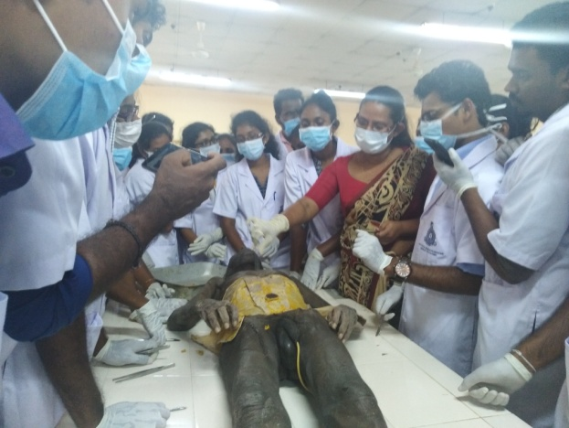

Academic unit of Allied Sciences is the common unit which was established for Ayurveda and Unani Study Programmes under Preclinical Sciences and also serves as a multidisciplinary division for the Institute. The unit engages in BAMS undergraduate and postgraduate teaching, practical works, and research which are relevant to the field of Ayurveda and in BUMS undergraduate teaching, practical works and research which are relevant to the field of Unani. The study programme of BAMS conducts the subjects such as Shareera Rachana, Shareera Kriya, Anatomy, Physiology, Forensic Medicine and Principles of Genetics, Molecular Biology and Bio Technology (optional). The study programme of BUMS conducts Anatomy, Physiology, Pathology, Forensic Medicine, and Principles of Clinical Medicineunder well qualified academic staff.
Anatomy laboratory facilitates for cadaver dissections and pathology specimens. Anatomical model demonstration hall and physiology laboratory are established with modern technological equipments for the students’ practical and research purposes.
Previously, the Academic unit was named as the Academic unit of “ShareeraVignana”. Currently, it is named as the Academic unit of Allied Sciences and it has proposed to be changed as academic unit of “ShareeraVignana” in Ayurveda and Tashreekh-e-Badan WaManafi-ul-Aazain Unani of the proposed curriculum.

The aims and objectives of the Academic unit are as follows
- To provide Ayurveda and Unani medical graduates with knowledge and skills to practice Ayurveda and Unani Medicine scientifically

- To contribute the research works on basic and applied aspect of Shareera Rachana, Shareera Kriya, Anatomy and Physiology (Ayurveda, Unani and Modern) in collaboration with other disciplines and Institutions

- To provide a supportive environment for optimal teaching, learning, research and self development for the BAMS and BUMS students.
Academic Unit of Dravyaguna Vignana

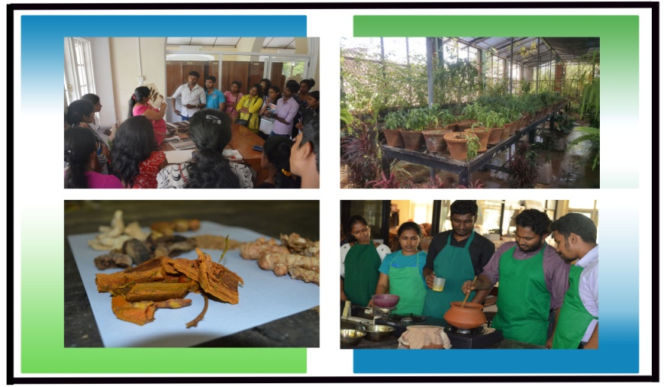

The academic unit of Dravyaguna Vignana has six divisions; Namarupa Vignana (Pharmacognosy), Guna Vignana (Study of drug properties), Karma Vignana (Pharmacology), Prayoga Vignana(Clinical pharmacology), Yoga Vignana (Study of drug preparation), and Kalpa Vignana (Pharmaceutics). This Unit is engaged in teaching and conducting practical training for level I, II, III undergraduate and postgraduate students and also conducts short courses in three subjects viz. Dravyaguna Vignana (Ayurveda Pharmacology), BhaisajjyaKalpana (Ayurveda Pharmaceutics), and Rasa Shastra (Alchemy) Also conduct short course and collaborative programme with other university and private sector.
The unit also organizes field visits toGanewatta, Peradeniya, Haldummulla and Pattipola herbal gardens, and Ayurveda drug cooperation and a private drug manufacturing companies. The unit also maintains an herbal garden in collaboration with the Institute of Agro technology and Rural Sciences of University of Colombo at Weligatta in Hambanthota District. Collaborative programs are also conducted with the private sector such as JAPA program which is conducted in collaboration with Japan and Tree of life Nature resort. Furthermore, the unit conducts collaborative research and product development research activities.

Aims and objectives of the Unit of Dravyaguna Vignana
- Provide knowledge of the identification, classification, and therapeutic actions of medicinal plants Mercury and other minerals used in Ayurveda and traditional medical systems.
- To impart the knowledge of comprehending the collection, preservation, storage, preparation and administration of herbal and herb-mineral medicinal preparations used in the Ayurveda and traditional medical systems.
- Dissemination of knowledge and providing laboratory facilities in order to conduct their relevant researches and drug development related to Ayurveda and traditional medicine.
- Maximum utilization of conventional methods, knowledge, and modern technology to facilitate good manufacturing, good laboratory, and good agricultural practices.
Academic Unitof Swasthavritta

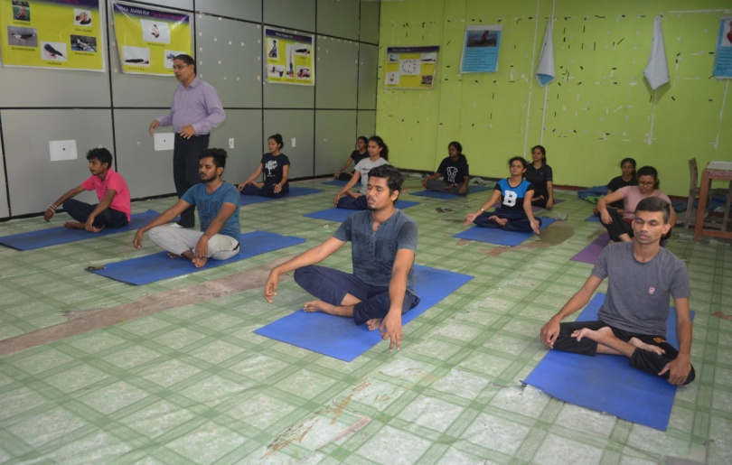

Ayurveda being a holistic science of life, it has the foremost aim to preserve the health of healthy individual and provides the preventive, promotive and curative aspects of positive health. The term Swasthavritta denotes the way of living healthy, which is known as Preventive and Social Medicine or Community Medicine.

The goals of the academic unit of Swasthavritta are to gain knowledge on promotion of positive health and prevention of diseases and to promote the physical, mental, social, and spiritual wellbeing.

The subjects offered from the academic unit are Research Methodology and Bio Statistics for Level II BAMS, Swasthavritta (Community Medicine) for Level III BAMS as core course units and Yoga and meditation and Ayurveda Roopalavanya Sanrakshana (Ayurveda Beauty Care) for Level IV BAMS as Optional course units. Under the Practical component, the academic unit is conducting clinical training in OPD at Ayurveda Teaching Hospital Borella, Yoga practical at the Yoga Centre and practical for RoopalavanyaSanrakshana at the Spa centre at the institute. Educational Field tours included under the academic unit are Water purification centers, Slaughter House and Port Health Authority. In addition to these activities field surveys are conducted by Level III BAMS students for the subject of Swasthavritta.
To fulfill the social responsibility the academic unit is organizing community based awareness programmes and health camps annually in collaboration with the students.
Yoga center and SPA centre are included under the infrastructure facilities of academic unit of Swasthavritta.

Academic Unit of Kaya Chikitsa

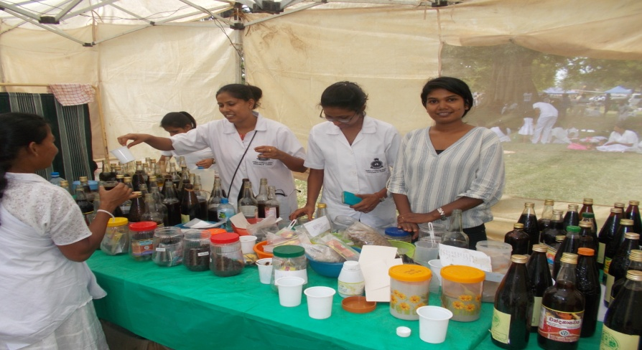

Since its establishment in 1929, the academic unit of Kaya Chikitsa has been an integral part of Institute of Indigenous Medicine, University of Colombo. It continues to provide innovative Ayurveda medical education and cutting edge discoveries, and delivers competent and compassionate patient care at the Ayurveda Teaching Hospital, Borella.
The academic unit of Kaya Chikitsa provides excellence in teaching, research, and clinical services related to the nature, cure, and prevention of diseases. We are committed to providing innovative and world-renowned Ayurveda general medical training to develop the next generation of Ayurveda medical leaders. Our Ayurveda clinical medicine programme provides core clinical training to undergraduate level III, IV and level V and postgraduate students. We offer broad clinical experiences through various disciplines to the highest professional standards to identify the Ayurveda path physiological mechanisms, and to prevent and treat diseases.
Academic staff members continue to excel in Ayurveda clinical medicine; Panchakarma, Rasayana and Manas Roga in the field of Kaya Chikitsa. The academic unit staff expertise includes areas of Ayurveda pathology, laboratory medicine involved in both basic science and healthcare delivery. Senior academics, technical and support staff members help to achieve our goal of improving health education and health care locally and globally.
A successful partnership with Ayurveda teaching hospital that emphasize innovation and care, allows us to attract the top medical minds and undergraduate and postgraduate researchers. We aim to build a successful foundation for the next generation of the health care leaders. Members of the academic unit regularly present their findings at local, national, and international conferences and publish in national and international publications.

Academic Unit of Shalya Shalakya

The academic unit t of Shalya Shalakya provides teaching and training in Shalya and Shalakya for undergraduates and post graduates along with its clinical services to a large segment of the population. Shalya Thantra is one of the eight branches of Ayurveda which makes a sustained contribution in the fields of ano-rectal diseases wound management, urinary disorders and fracture healing where ancient clinical and surgical procedures are practiced. Shalya Thantra explicit many surgeries which are more advanced than that of the present era. Shalakya Thantra is the branch of Ayurveda which deals with the diseases above the clavicle viz. head and neck portions of the body. Shalakya Thantra focus on Netra Chikitsa (Ophthalmology), Karna Chikitsa (Otology), Nasa Chikitsa (Rhino logy), Mukha roga Chikitsa (Oral medicine and Dentistry) and Shiro roga Chikitsa (diseases of the cranium) with special treatment procedures which effectively manage eye, ear, nose, head and throat diseases. However, the accurate and timely diagnosis of disease continues to be an important aspect as well as the patient safety has become an essential component in quality healthcare. In depth learning and training in Shalya and Shalakya fulfill the current national requirements in the field of Ayurveda addressing the global trends.

Aims and objectives of the academic unit of Shalya Shalakya:
- To disclose a profound knowledge of Shalya and Shalakya supplemented with knowledge of modern advances to be efficient physicians, surgeons, and researchers fully competent to serve the National health care services.

- To enable undergraduate and post graduate students to identify and manage surgical problems, eye, ear nose, head and oral diseases through Medicinal, Surgical, and Para-surgical treatment modalities.

- To build a Professional with commitment, is ethical and understands legal responsibilities accountable to patients, community, and profession.

Academic Unit of Prasuthi Thantra Kaumarabhritya
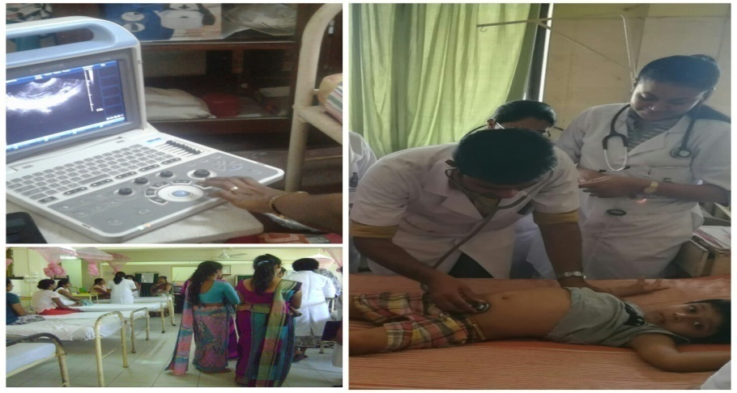

The academic unit of Prasuthi Thantra Kaumarabhritya is responsible for teaching the compulsory subjects of Stree Roga Prasuthi Thantra (Gynecology and Obstetrics), BalaRoga (Pediatrics) BAMS Level V students, and Optional subject of Reproduction and Genetics for BAMS Level IV students. The clinical programme of the academic unit is conducted at the National Ayurveda Teaching Hospital Colombo. The Prasuthi Thantra encompasses the study of normal and abnormal pregnancy. In StreeRoga the main areas of interest are in reproductive and sexual health, fertility control, disorders of the female genital tract and menopausal issues. The teaching program of BalaRoga includes bed side teaching in the ward and clinics to maintain general health states of children and managing their pathological conditions.

Vision of the Academic Unit
To be the leading academic unit in Prasuthi Thantra Kaumarabhritya in imparting knowledge, skills and attitudes towards child survival and safe motherhood

Mission of the Academic Unit
To provide adequate training opportunities to develop skills, knowledge and attitudes to produce Ayurveda graduates, self empowered to practice at a primary health care level to promote, prevent, preserve, and treat common gynecological, Obstetric and Pediatrics conditions.

Academic Unit of Desheeya Chikitsa

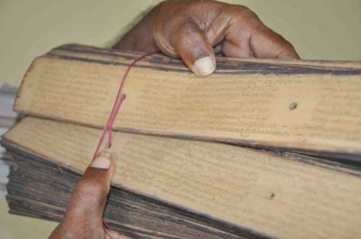

Every country has its own medicinal system known as traditional or indigenous medicine this plays a major role in their primary health care of this country. Sri Lanka has a rich traditional medicinal system practiced from the time of king Rawana. Before the arrival of Ayurveda from North India to Sri Lanka there had been an indigenous system of medicine practiced from time immemorial in the island. This view has been proved with the invention of historical evidence such as excavation of ruins of an ancient hospital in Mihintale. This empirical indigenous system of medicine had several prominent disciplines practiced by different traditions (Guru Kula). Out of these expertises Kadumbindum, Sarpavisha, Unmada, Akshiroga, Gedivanplika, Vidumpillissum, Devumpillissum, Mandam vedakama etc became very much popular among people of the Island. With the propagation of Ayurveda in Sri Lanka after arrival of Mahinda thero the indigenous system of medicine started to be blended with the major theories of Ayurveda. Therefore the indigenous medicine practiced today in the island is an amalgamation of indigenous system of Ayurveda.

Indigenous system is very rich in unique medical preparations, prescriptions, pharmaceutical products, techniques of diagnosis, therapeutic techniques etc. the purpose of incorporation of the subject of Desheeya Chikitsa is to protect, preserve, nature, develop and propagate the indigenous system in Sri Lanka. Thereby it is aimed at getting maximum benefit out of the people of the island.

The aims and objectives of academic unit are;
- To impart detail knowledge pertaining to the various indigenous medical expertise to the students.
- To facilitate student to practice indigenous medical expertise and utilize local natural resources in alleviating disease and prevent them.
- To enable student to understand and to practice indigenous diagnosing techniques and therapeutic techniques.
- To develop the skills of the students to prepare Desheeya Kasaya (Decoction), Guli (Pills), Churna (Powders), Taila (Oils), Patthu (Paste), Mallum etc.
Departments of Study (Unani Section)

Department of study in Unani

The IIM, University of Colombo is the only institute that provides the Unani medical Education in Sri Lanka. The Unani medical teaching is carried out at the institute since its inception in 1929. Unani medical division consists of 2 main study Programs such as undergraduate (BUMS) and P.G. Programs.
The Unani medical teaching is carried out by 8 academic units of the Unani Section. They include clinical and non-clinical related subjects and the undergraduates and P.G. students of the Unani medicine. There academic unit directly responsible for teaching training and evaluation of the undergraduate and P. G students. There is a growing demand for health care services with traditional medical treatment modalities including Unani medicine. This situation completed the world health organization take medical measure improves the traditional medical health care suit the expectation o the present society.
History of Unani Medicine begins with the age of Pericles (562-430B.C) and it was developed during the Arab civilization. Hence, it is also known as Arab medicine. The Arabs, who were seafarers in mediaeval time, had commercial links mainly with India, but later they resorted to direct trade with Sri Lanka. As a result, many of them settled down in Sri Lanka, especially in the coastal areas. The Muslims of Sri Lanka disseminated & preserved this system even in this 21st century. Its dominating figure was Boharath (Hippocrates 460-360 B.C) who is still preferred to as the “Father of Medicine”, and he was the authority of the humoral theory. The great Philosopher Arasthu (Aristotle 384-322 B.C) was the next prominent figure in Unani Medicine. Jalinoos (Galen 131-210 B.C) introduced his Anatomical knowledge to the Arabians. Since then there have been so many authorities who contributed towards the development of Unani system. Ibn Sina (Avicenna 937-1037) was the most famous Physician and Philosopher in Unani Medicine System. Among his contribution to medicine “Canon of Medicine” which is an encyclopedia and text book of medicine is the best.
Head of the department of study in Unani
Dr. B.M. Nageeb
Senior Lecturer Grade I, DAMS (Hon) (Colombo), M Phil Unani (Colombo), PhD (Kelaniya)
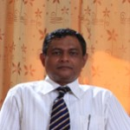
Academic Unit of Kulliyath

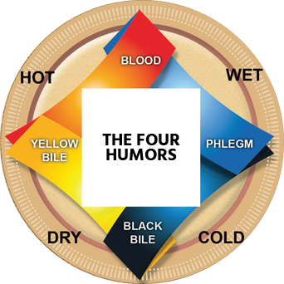

The academic unit of Basic principles is among the first subdivisions established in Unani section. This academic unit is an important one and the back bone of Unani Medicine. The theoretical framework of Unani medicine is based on the work of Hippocrates (460-377 BC). By his method of careful study and comparison of symptoms, he laid down the foundation for clinical medicine based on diet and rest. Educate the undergraduates and make practicing the Mizaj concept and research is responsible in this academic unit. academic unit of Kulliyath contains all the basic principles of Physiological and a therapeutically aspect of Unani Medicine.This department has started to guide postgraduate diploma in Unani. The knowledge and skills of the studies are imparted to develop competent physicians to the world.
The main goal of the academic unit is to achieve excellence in teaching, research, and clinical services in Unani fundamental theories /concepts/philosophies without ignoring scientific view of the same, along with its history &language. The academic unit strives to bring about progression in the science of Unani Fundamental Medicine through innovation and enterprise.The main Objectives of our academic unit are to comprehend the philosophical aspects of medical systems, to identify non-physical entities of traditional Unani system, to apply philosophy, non-physical entity in medical practice to invigorate the modern Unani System, to comprehend the historical value related to indigenous medical systems, to recognize and develop medico-cultural relationship in Unani medical field among SAARC and Middle East countries, to understand the past, to put the best into practice in the present, to plan a better future in the medical field, to pronounce Urdu and Arabic words, especially Unani Medical Terms and to comprehend both modern and classical texts of Unani Medicine in Urdu and Arabic.
In order to assure the quality of our academic unit, we ensure implementing various practices such as, strictly following assignment deadline, conducting departmental monthly meetings, and conducting departmental lecturers with student meetings etc.
Strength of our department is arranging public awareness programs for the wellbeing of public and to make awareness of the Unani Medical system among public.

Academic Unit of Ilmul Advia

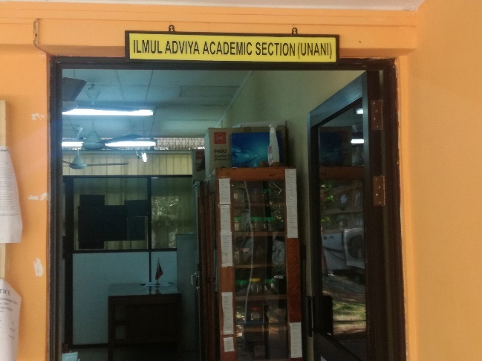

Unani System of Medicine was academically established along with the Ayurveda and Siddha systems of medicine at the College of Indigenous Medicine in 1929. Since then it has been playing a major role in teaching and preserving the Unani System of Medicine in Sri Lanka. It is located adjoining the border of heritage administrative capital Sri Jayewardenepura Kotte of Sri Lanka. Later, it was affiliated to the University of Colombo in 1977. The academic unit of Ilmul Advia (academic unit of Unani pharmacology) of the Unani Section offers subjects of Kulliyath e Advia, MufratAdvia, DawaSazi,andKusthaSazi , which spread over Level I, Level II and Level III. These subjects are essential components of the BUMS curriculum. Further it offers Nutrition and Food cum Medicine, Industrial Drug Manufacturing and Agro Techniques of Medicinal plants as optional subjects which support and strength the Ilmul Advia. The academic unit strives hard to maintain academic excellence in all areas of studies of the academic unit. In addition, the academic unit also engages in Community Development Programmes such as conducting awareness programs, workshops and other activities.

Objectives of Academic unit

To contribute to the development of a well-rounded Unani medical graduates who will demonstrate knowledge and competent with compassion in dealing with primary health care, desire for lifelong learning, evidence base practice and interdisciplinary team work in order to improve and sustain the health of the population.

To ensure that the medical graduate has acquired broad preventive health competencies needed to solve health problems of the community with the emphasis on health promotion, disease prevention, and cost-effective holistic interventions utilizing indigenous medical knowledge.

Academic Unit of Tahaffuziwa Samaji Tib

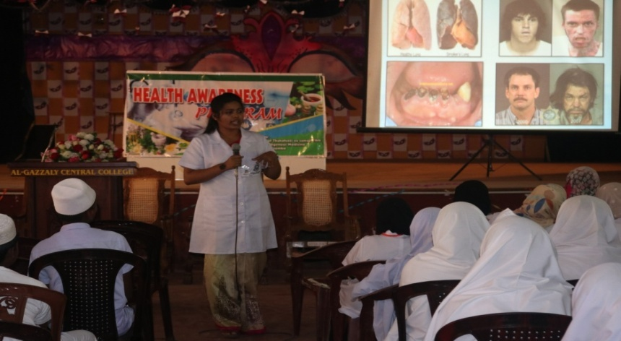

We as the academic unit of Tahaffuziwa Samaji Tib(TST), (Preventive and Social Medicine, Unani) under the Unani section of Institute of Indigenous Medicine strives to maintain academic excellence in all areas of departmental study. The academic unit of TST also involves several other activities, such as conducting special OPD at Ayurveda Teaching Hospital Borella and health awareness and health promotion programmes under community engagement in various part of Sri Lanka. Following subjects are being taught from Level II BUMS to Level IV BUMS to meet the intended learning outcomes as per the curriculum. Core subjects are Research Methodology and Bio Statistics, Tahaffuziwa Samaji Tib, Community Medicine and Ilmus Sumoom. Herbal Beauty Culture and Drug Abuse Management as optional subjects.

Field health activities and other students centered field programs:

According to the Level III of the BUMS curriculum the subject of Tahaffuziwa Samaji Tib (Preventive and Social Medicine, Unani) consists of community based health educational programmes focusing to identify the health related problems among the general public and to implement health educational interventions by engaging Level III BUMS students. Further Level III BUMS students participate in practical sessions by visiting water purification plants as well as at Slaughter house on hygienic meat production under the same subject.
Level IV BUMS students visit National Zoological Garden for practical training on identifying poisonous snakes under Ilmus Summom subject. Further the same Level IVBUMS student also engage in practical sessions at rehabilitation centers for drug addicts under the subject Drug abuse management.

Academic Unit of Moalijat

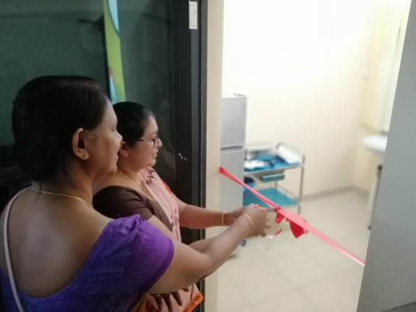

The academic unit of Moalijat has 8 permanent academic members, a temporary demonstrator, and 3 visiting lecturers. The academic unit is mainly dealing with the undergraduates Clinical programmes of the of the BUMS curriculum. The clinical programmes start from level III to Level V and comprises 3 core subjects namely Principles of Diagnosis, Fundamental of treatment, Unani Clinical Medicine. In addition to this there are 3 optional subjects namely Massage and Physical Therapy, Counseling & Psychotherapy and Punchakarma. The academic unit established a Regimental Therapy Unit recently in order to further upgrade the Regimental therapy medelities to meet the growing demand.
The clinical training is mainly provided at the Teaching Hospital of Ayurveda with the participation of the teachers of the academic unit of Moalijat and the Unani Physicians of the Teaching Hospital of Ayurveda.
In addition to the undergraduate programmes the academic unit also involves in teaching and training of the Postgraduate scholars.
The academic members of the academic unit provide healthcare service to the public at the Teaching Hospital of Ayurveda on honorary basis.
The academic members of the academic unit of Moalijat involve in research activities including the undergraduate research programme for the Level IV students.
The academic unit of Moalijat also conducts community based programmes such as Health camps, Health promotion awareness programmes through electronic and Mass media.
The academic unit is now working to establish a Clinical Skills Development Laboratory and the Pathology Museum in order to produce competent Unani Medical graduates to meet the national and global demand.
Further the academic unit has taken a decision to train the trainers in order to update their knowledge and skills.

Academic Unit of Ilmul Jarahat

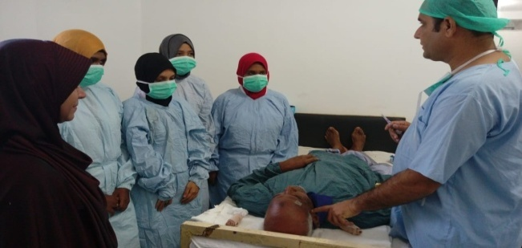
The academic unit of Ilmul Jarahat basically offers lectures and practical trainings on surgery and Ear, nose, throat and ophthalmology and assist the smooth functioning of 285 direct student contact hours in the course units of Ilmul Jarahat (Unani Surgery) and Amraz e Ain AnfUznvaHalq (ENT Ophthalmology and Othodontology). The total credits offered by the Department of Ilmul Jarahat are 14 (lectures 135 hours and practical training 150 hours). Therefore, the academic unit plays an important role in disseminating knowledge and developing skills of the undergraduates with expected competencies which are vital to their sustainable and successful career as medical practitioner and researcher.
The main Objectives of our academic unit are to Identify the problems at the first level of case and be able to refer whenever necessary, Diagnose and manage common surgical conditions according to Unani concept as well as modern science, Diagnose and perform operative procedures in minor surgical conditions; Competent with the capabilities of diagnosis and management of disease related to Eye, Ear, Nose, Throat (ENT) & Oral cavity, Impart modern scientific methods and materials related diseases of Eye, ENT & Oral cavity. The specific Strategic Objectives are to uplifting infra structure facilities and Establishment of skill Laboratory.
We have adopted interactive teaching methods in our teaching practice such as students led seminars, Reflective practice, self - directed learning, case studies, short clips, group activities, assignments etc. at the end of the each semester, students’ feedback is obtained from the students to improve the quality of teaching and peer-review assessment is practiced to enhance the teaching modality of lecturers.
The practical sessions of Eye, ENT and surgery are conducted at National Ayurveda Teaching Hospital (NATH) Borella. A well prepared, informative student guide book is provided to each and every student to understand the role of them in the academic unit. In order to assure the quality of our academic unit, we ensure implementing various practices such as, strictly following assignment deadline, using video clips to demonstrate surgeries, conducting academic unit monthly meetings with student representative etc. Strengths of our academic unit are arranging and participating medical camps, practical observation on cataract surgery, training program on circumcision and first aid.
Academic Unit of Amraz e Niswan, Qabalat va Atfal

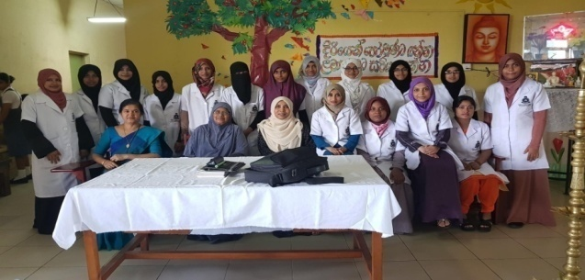
The academic unit of Amraz e Niswan, QabalatvaAtfal basically offers lectures and practical trainings on Unani Gynecology, Obstetrics and Pediatrics and assist the smooth functioning of 270 direct student contact hours in the course units of Amaraz e Niswan (Gynecology), Qabalat(Obstetrics) and Atfal (Pediatrics).The total credits offered by this academic unit are 19 (lectures 180 hours and practical 210 hours). Therefore, the academic unit plays an important role in disseminating knowledge and developing skills of the undergraduates with expected competencies which are vital to their sustainable and successful career as medical practitioner and researcher.
The main Objectives of our academic unit are to Identify common Paediatric, Gynaecological and Obstetrical problems and compare & Contrast the pathological changes based on Unani and modern medical systems, to Guide the caregivers to promote and maintain health during childhood, reproductive age and menopausal period, Manage paediatrics, gynaecological & Obstetrics problems with appropriate Unani treatment modalities and to refer when necessary and Handle normal labour and identify major deviation and refer cases to the relevant institutions if required. The specific Strategic Objectives are uplifting infrastructure facilities and Establishment of skill Laboratory.
We have adopted interactive teaching methods in our teaching practice such as students led seminars, Reflective practice, self - directed learning, case studies, short clips, group activities, assignments etc. at the end of the semester, students’ feedback is obtained from each and every student to improve the quality of teaching. Also, peer-review assessment is practiced to enhance the teaching modality of lecturers.
In order to assure the quality of our academic unit, we ensure implementing various practices such as, strictly following assignment deadline, using video clips to demonstrate deliveries, conducting academic unit l monthly meetings with student representative etc.
Strength of our academic unit is arranging public awareness programs on nationally and internationally declared health related days, weeks, and months. Respective programs are conducted in the schools and other areas where relevant target group is identified.

Academic Unit of Desheeya Ilaj

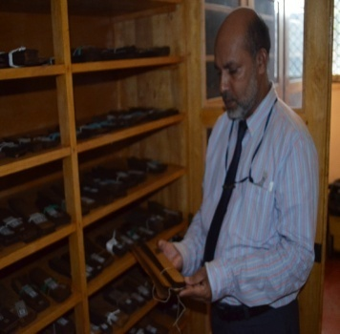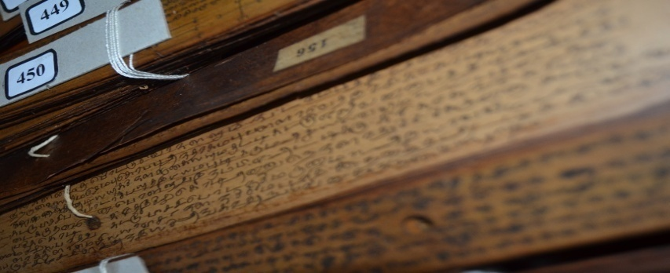
The academic unit of Desheeya Ilaj (DI) basically offers lectures and practical trainings on Unani Traditional medicine; assist these mouths functioning of the course units of DI. The total credits offered by this academic unit are 07 (lectures 60 hours and practical 90 hours). Therefore, the academic unit plays an important role in disseminating knowledge and developing skills of the undergraduates with expected competencies which are vital to their sustainable and successful career as medical practitioner and researcher.
The main Objectives of our academic unit are to Identify common Medicinal plant using in Unani Traditional medicine and problems and compare & Contrast the pathological changes based on Unani and Traditional medical systems, Manage children,& gynaecological (Pennoykal) problems with appropriate Unani and traditional treatment modalities and to refer when necessaryand refer cases to the relevant institutions if required.
We have adopted interactive teaching methods in our teaching practice such as students led seminars, Reflective practice, self - directed learning, case studies, short clips, group activities, assignments etc. at the end of the semester, students’ feedback is obtained from each and every student anonymously to improve the quality of teaching. Also, peer-review assessment is practiced to enhance the teaching modality of lecturers.
The practical sessions of Desheeya Ilaj conducted at National Ayurveda Teaching Hospital (NATH) and Various Traditional Physician clinic. Students are instructed to follow up each in-warded case, even follow up visits under the supervision of consultant /lecturer.
A well prepared, informative student hand book is provided to each and every student to understand the role of them in the academic unit. In order to assure the quality of our academic unit, we ensure implementing various practices such as, strictly following assignment deadline, using video clips to demonstrate deliveries, conducting academic unit monthly meetings with student representative etc.
Strength of our academic unit is arranging public awareness programs on nationally. Health related days, weeks, and months. Respective programs are conducted in the schools and other areas where relevant target group is identified.
Information Technology Section

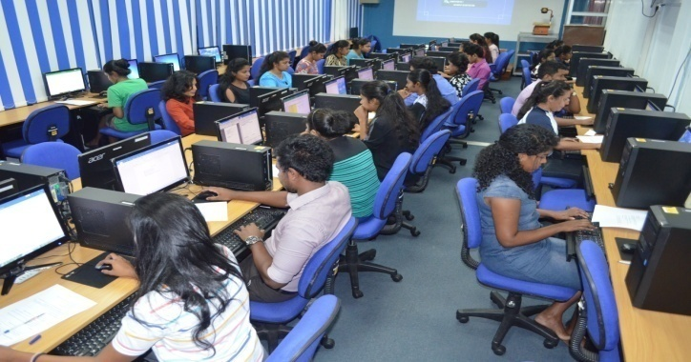
Information Technology Section established in 1986 as Audio Visual Unit under donation provided by the government of Japan. At the beginning Audio Visual Unit was limited to few functions. With the development of information technology, enhanced the IT services and changed the name as Information Technology Section.
Information Technology Section is the main Information Technology resources provider for the Institute of Indigenous Medicine. IT Section is equipped with main Auditorium, Mini Lecture hall, and two computer labs, with a total number of 50 client machines which are allocated for Students as well as for lecturers. One computer lab has been exclusively reserved for free use by students and the other lab is mainly used for practice under the supervision of a lecturer. IT Section conducts IT lectures for Ayurveda students and Unani students. Further IT Section provides Internet facilities, photography facility, sounds facilities, IIM domain email creation facility, and computer repairing and software installation facilities to the IIM. IT section is the main authorized party for handle websites and Learning Management System (LMS) of the IIM.According to the request we update the main website or we develop new websites.
IT section is headed by academic staff member and it also consists Two Computer Instructors, Assistant Network Manager, Technical Officer, and Two Lab attendants. We work as a team for to provide best IT related services to the IIM.
The Information Technology Section is open on week days except on public holidays from 8 a.m. to 5.30 p. m. The said time period may be varied on institutional needs.

The Library

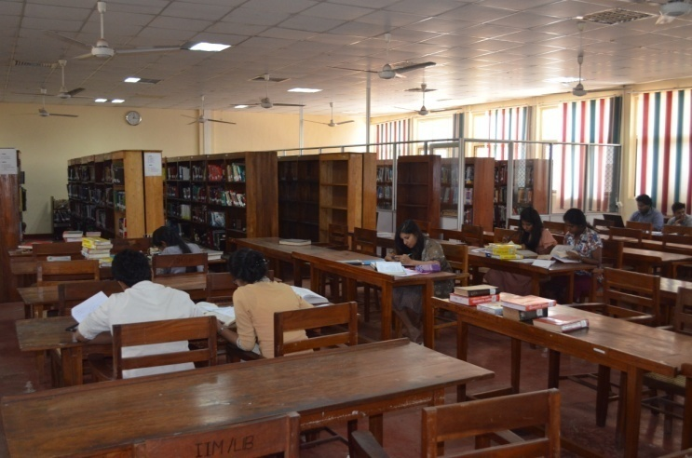
The library of the Institute of Indigenous Medicine, University of Colombo was founded in 1929, the same year that the Ayurveda College was inaugurated. This Library is the oldest and the largest Ayurveda medical library in Sri Lanka. The main book collection has over 35000 volumes of books. This comprehensive collection mainly covers a wide range of medical books related to Ayurveda system of medicine and Unani system of medicine and also other medical systems. Books on Ayurveda which is written in Sanskrit language and Unani books in Urdu language are among them. In addition to the Lending, Reference, Permanent Reference, Theses, and Archival collections there are three special collections comprising Medicinal plants, Ola leaf manuscripts and Hand written manuscripts.

All library resources are properly accessioned and recorded in catalogues, according to the second edition of Anglo American Cataloguing Rules (AACR) 2 and according to the Dewey Decimal Classification (DDC) System for easy access of users. The whole library collection has been computerized according to the “KOHA” Software. Readers can access to library resources through online public Access catalogue (OPAC). The library provides various services and facilities including Reader service, Inquiry service, Photocopying service, Inter library loan service, Document delivery service, Scanning service, and User education programmes etc. The library consists of Permanent Reference Section, Reference Section, Lending Section, Periodicals Section, Ola Leaf Manuscripts Section, Archival Section, Photo-coping Section, and the Bindery.

At present the library expanded its services to meet information requirements of Undergraduate and Postgraduate students and also Academic and Non-academic staff. The library of Institute of Indigenous Medicine is one of the member libraries of Health Literature Libraries and Information Services Network (HeLLIS) and Sri Lanka Scientific & Technological Information Network (SLSTINET).

Student Population at IIM

The Distribution of the student population of the institute among the sections is given in the following table.

Undergraduate Student Enrollment
Intake | Ayurveda |  |  | Unani
 | Male | Female | Total | Male | Female | Total
2017/18(New Batch) | 44 | 136 | 180 | 5 | 48 | 53
2016/17 (1st year) | 38 | 143 | 181 | 6 | 49 | 55
2015/16 (2nd year) | 31 | 119 | 150 | 3 | 31 | 34
2014/15 (3rd year) | 29 | 102 | 131 | 13 | 33 | 46
2013/14 (4th year) | 27 | 106 | 133 | 7 | 36 | 43
2012/13 (5th year) | 22 | 133 | 155 | 13 | 32 | 45
2011/12 (5th year) | 19 | 79 | 98 | 5 | 43 | 48
Total | 166 | 682 | 1028 | 47 | 224 | 324
Total No. of Student :- | 1352
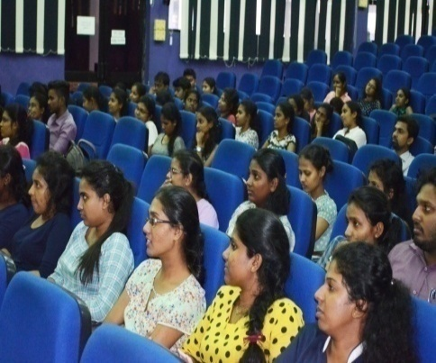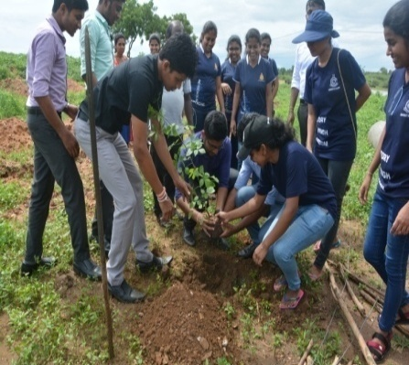
Auditorium of the Institute Waliyaththa Medicinal Garden

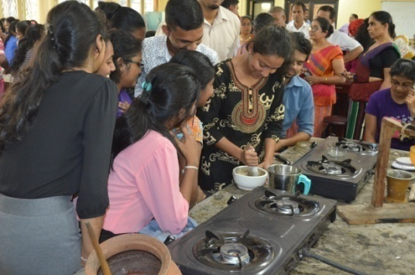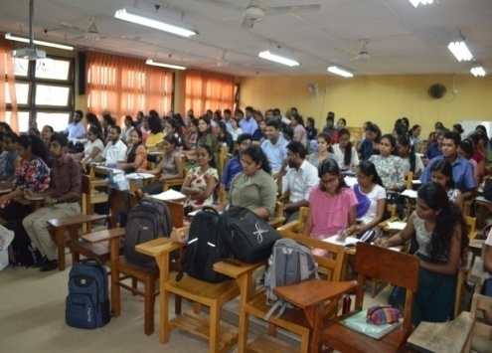
Pharmacy of the Institute Ayurveda Lecture Halls

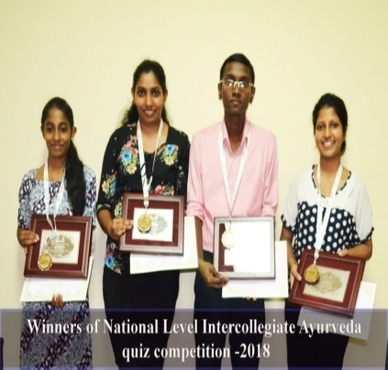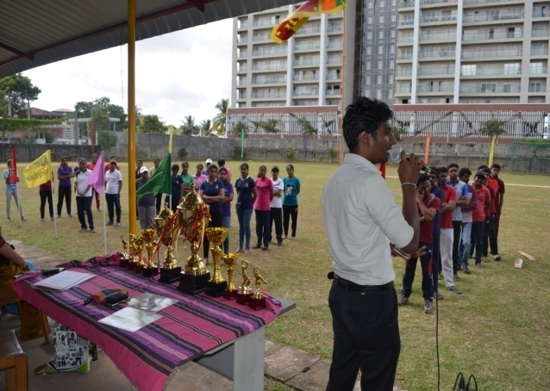
Winners of National Level Intercollegiate APL 2018
Ayurveda quiz compitition - 2018

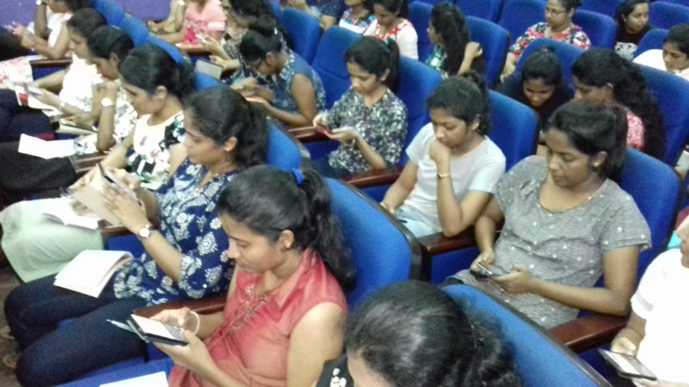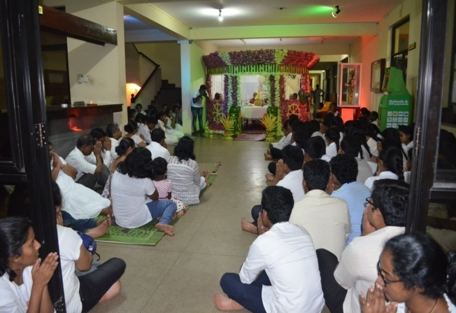
Learning Management System (LMS) Annual Pirith Chanting Ceremony
workshop conducted for Level IV 2018
BAMS(2013/2014) batch
Committees of the Institute

DEPARTMENTAL COMMITTEE OF AYURVEDA

Departmental Committee is entrusted with the responsibility to make recommendation on all matters connected with the courses of study, teaching programmes and examinations in the relevant branches of Indigenous Medicine. In terms of section 15(1) of the Institute of Indigenous Medicine ordinance No. 7 of 1979 the Academic Committee 2013 has been constituted. Chairperson of Ayurveda Departmental Committee – Sectional Head/ Ayurveda Dr.(Mrs.) KC Perera. All permanent Lecturers are members of the Ayurveda Departmental Committee.

DEPARTMENTAL COMMITTEE OF UNANI

Departmental Committee is entrusted with the responsibility to make recommendation on all matters connected with the courses of study, teaching programmes and examinations in the relevant branches of Indigenous Medicine. In terms of section 15(1) of the Institute of Indigenous Medicine ordinance No. 7 of 1979 the Academic Committee 2013 has been constituted. Chairman of Unani Departmental Committee – Sectional Head/ Unani Dr. BM Nageeb. All permanent Lecturers are members of the Unani Departmental Committee.

THE QUALITY ASSURANCE CELL

Institute of Indigenous Medicine established the Quality Assurance Cell (QAC) in par with the guidelines given in the manual published by the QAC of the UGC for public universities. The QAC comes directly under the Director of the IIM. The goal of the QAC shall be to create a culture that continually improving the quality of all academic related activities of the IIM. For this purpose QAC published the manual on "Standard Operational Procedures".
Major functions of the QAC can be categorized as follows:

- Develop policies and procedures especially to improve the quality of teaching and learning activities, examinations, and research and student support systems.

- Liaise with the QAC in facilitating the conduct of external reviews in the IIM.

- Guide/assist Ayurveda Sectional Committee and Unani Sectional Committee in preparation of self-evaluation reports for the institutional review and the programme review.
- Submit QA review report annually to the senate council

- To facilitate the implementation of the follow-up actions recommended by the Higher Education Ministry for the programme or institutional review reports, and monitor progress in their implementation.

- To liaise with quality assurance activities and share good practices especially in:
- Maintenance of the quality and standards of the examinations and assessments
- Maintenance of ethics and standards of students, staff, examinations, and research
- Ensure financial viability and availability of financial resources
- Professionalize the administration process

- As the Institute of Indigenous Medicine is a small institute, Staff Development activities are also organized by the QAC.

FINANCE COMMITTEE

Objective
The finance committee is a sub committee of the board of management of the institute, responsible for all matters relating to the financial affairs of the institute, the areas of strategic financial planning, resource management, financial monitoring, and policy related issues and to provide timely advice to Board of Management (BOM) on areas within its responsibility.

Membership of the committee
The committee, which shall be appointed by the Board of Management.

Members
- Dr.MDJAbeygunawardhana- Chair person
- Prof. KapilaSenevirathne- Member
- Mr. MDD Peiris- Member
- Prof. PA Paranagama- Director, Member
- Mr. MI Warnasooriya -Deputy Registrar, Member
- Mr. HMG Punchibanda-Senior Assistant Bursar,Member

Period
Membership of the committee are appointed to a period of three years

Meetings
The committee shall meet at least quarterly throughout the year.
Duties
Develop and review policies relating to the financial management of the institute and recommended to the board of management for approval

ADMINISTRATIVE STAFF MEETING

Administrativestaff meeting of the institute has been established to discuss the matters pertaining to the administration.
The members of the administrative staff meeting are as follows

- Prof: PA Paranagama– Director
- Dr.(Mrs.) KC Perera - Head/ Ayurveda
- Dr. BM Najeeb - Head/Unani
- Mr. ML Warnasooriya– DeputyRegistrar
- Mr. HMG Punchibanda - Senior Assistant Bursar
- Mr. PHU Nishshanka - Senior Assistant Bursar
- Dr. (Mrs.) CK Gamage- Senior Assistant Librarian
- Ms. HD Dissanayake - Assistant Registrar
- Mr. DSRMCP Gunawardane - Assistant Registrar
- Mr. KCS Ranasinghe - Assistant Network Manager

It will be held in the 1st Wednesday of every month.

Discussion regarding the progress of the administrative of every section is done by each meeting.

RESEARCH MANAGEMENT COMMITTEE
Apart from teaching, Academics of the Institute of Indigenous Medicine (IIM) are entrusted to explore the innovative knowledge through research activities and to serve to the community through developing the field of Ayurveda, Unani, and Traditional systems of medicine.
The main objective of the RMC is to assist the academics in the IIM to contribute to the filed of Ayurveda, Unani and Traditional systems of medicine through high quality research and disseminating such research knowledge to the community partnership programs.
Objectives of RMC
- To strengthen the sustainability of the IIM
- To take full advantage of the value and usefulness of academic and intellectual resources
- To increase national and global contribution of the IIM
- To improve the image and raise the rank of the IIM
Composition of the Research and Management Committee
The committee is composed of following members elected by the Board of Management.
- Director, Chairperson the committee.
- All the Senior Professors / professors in Ayurveda and Unani sections
- Heads of the department of study in Ayurveda &Unani
- Heads ofthe Academic Unit ofAyurveda and Unani

ETHICS REVIEW COMMITTEE (ERC)

The Research ethic Review Committee of the Institute of Indigenous Medicine (ERCIIM), University of Colombo was established in 2011. It is a 17 member committee consisting of members nominated from Institute of Indigenous Medicine and other universities or institute with experience and knowledge in research in different fields. Present chairperson of the ERCIIM is Prof. (Mrs.) ERHSS Ediriweera and the secretary is Senior Lecture Dr. (Mrs.) RDH Kulathunga. The ERCIIM reviews all research projects including research involving human and animal subjects.
ERCIIM ensure that the safety and rights of research participants and the researcher are protected and the obligation to the society is fulfilled.
ERCIIM protects the mental and physical welfare, rights, dignity and safety of human participants and animals used in research and facilitate ethical research by effective and efficient review and monitoring processes in accordance with national and / or local regulations, as well as with World Health Organization (WHO) Good Clinical practices (GCPs) guideline. ERCIIM helps to promote evidence-based bio medical research for upgrading the Ayurveda/ Traditional/ Indigenous and Integrated system of medicine.
Ethic Review Committee of IIM,3rd January of 2019 University of Colombo as approved by the Ministry of Health Nutrition & Indigenous Medicine.

GRIVANCE COMMITTEE

The institute has established a grievance committee to look in to complaints made by employee and students with the guideline given below.
- The Grievance committee determine whether the formal written grievance submitted by themembers of the institute has a matter that is within the jurisdiction of the committee and if so, to hear the grievance.
- Members of the Grievance Committee are expected to attend the initial orientation meeting and scheduled hearing dates to discuss the cases that have been forwarded.
- Members of the committee must at all times maintain a neutral status vis-à-vis the parties tothe grievance and must be fair impartial decision makers with high level of integrity and trust.
- The Committee’s role is to listen and review all testimony and documentary evidence presentedduring the hearing to make a decision based on the evidence presented by each party.
- Committees members must be open minded and not presume that either party to the grievance is right or wrong. They should be able to weigh the credibility of the evidence, make specific findings of fact, and determine whether the grievant has established the charges.
- The grievance procedure requires at least three members form the grievance committee to hearthe grievance and decides the action while a non-voting chair presides over the process.
- The Committee is responsible for making written findings of facts and recommendations with regard to the grievance and assist chair in finalizing the written report of the committee’sdecision.
- The committee must maintain confidential records for each case.
- It is important to ensure that the process that is followed by the grievance committee is fundamentally fair to all parties and complies with the university procedures.

Members of Grievance Committee
- Prof. C Fonseka - 88/14, Ferry Road, Etul Kotte.
- Ms. MADSJS Niriella - Head/ Dept. of public & international law, faculty of law, University of Colombo, Colombo 03
- Prof. J Welihinda - 85, Watarappala Road, Mt Lavinia
- Prof. W Yapa - Dept. of Zoology & Environment science, Faculty of Science, University of Colombo, Colombo 03

HOSTEL COMMITTEE

Hostel Committee of Institute of the Indigenous Medicine is functioning as a main administration body which gives solutions to the all hostel issues. The committee meets, when some matters arrived. Mainly it decided to grant hostel facilities to students who are in need according to the facilities available.
Composition of the Hostel committee
- Director - Chairman
- Deputy Registrar
- Senior Student counselor
- Wardens - Girls & Boys hostels
- Sub Wardens - Girls & Boys hostels
- Assistant Registrar - Student Affairs (Secretary)

INTERNATIONAL COLLABORATION OF THE INSTITUTE

The institute has established international collaboration with recognized universities, research institutes and other relevant institutes in order to strength the teaching and research activities of IIM. Several Memorandum of Understanding (MOU) have been singed and details are given below.
- Memorandum of Understanding between Changchun University of Chinese Medicine, Jiling, P.R. China and IIM, University of Colombo, Sri Lanka.

- Memorandum of Understanding between Banaras Hindu University, Varanasi, UP, India and IIM, University of Colombo, Sri Lanka.

- Concept paper on Memorandum of Understanding between Japan Association for promotion of Ayurveda (JAPA), Japan, and IIM, University of Colombo, Sri Lanka.

- Memorandum of Understanding for the Establishment of the China- Sri Lanka Joint Laboratory for Natural product research and development.

- MOU between Institute of Indigenous Medicine and National Institute of Unani Medicine.

- MOU between Institute of Indigenous Medicine and Ahmed Ashraf Memorial Unani Specialty Treatment Centre for Paralysis.

SWOT ANALYSIS

SWOT analysis was carried out to have the gap and to identify future areas to be developed.
- Strengths

- Historical advantage

The IIM was established as the Swadeshiya Vaidya Vidyalaya (ස්වදේශ වෛද්‍ය විද්‍යාලය / College of Indigenous Medicine) on June 10, 1929, is the first Medical Collage for Indigenous Medicine. Accordingly the IIM has the historical advantage to benefit from the associated goodwill and privileges.
This is the oldest Indigenous Medicine Institute in Sri Lanka and celebrates the 90th anniversary in 2019.

- Extend of Land

Institute of Indigenous Medicine has possessed 10 Acres total land area which can be considered as strength for the future institutional development

- University state

The IIM is attached to the premium University of Sri Lanka, the University of Colombo. As the University of Colombo is the oldest and highest ranked university in Sri Lanka, the graduates of IIM receive international recognition and foreign collaboration.

- Locational Privilege

Since the IIM is located in Sri Jayawardhanapura Kotte, which is the administrative and business capital of the country, the institute is easily accessible to the stake holders. This has been a great advantage for the institute when catering its service. In addition a light railway system has been scheduled to be implemented by the government which reduce the traffic jam of the suburb, would further facilitate the accession to the Institute. The Ayurveda Teaching Hospital, which is used for clinical studies, is located close proximity of the Institute. This location is a great advantage for the undergraduates to obtain the clinical knowledge pertained to the field of Ayurveda/Unani easily. The mother University, the University of Colombo is also situated around 2 Km away from the Institute.

- Availability of infrastructure Facilities

Lecture halls, laboratories, Library, Information Technology Center, Herbal Garden, Play Ground, and Hostel facilities can be considered as strength to enhance the quality of the existing teaching and learning environment.

- Human Resources
IIM has strength of qualified academic, administrative, and administrative support staff. Most of the staff members have obtained their postgraduate qualifications in the relevant field from local as well as oversees universities. Thus, the IIM has the potential to conduct teaching and research for undergraduate as well as postgraduate degree programs in the Ayurveda/Unani to encounter national and international health problems.
- Library facility
The library of IIM has around 35000 of collection of books, journals, e-journals periodicals which are related to the indigenous medicine. In addition, the library contains a separate section, which has preserved 472 of ola leaf manuscripts. These ola leaf manuscripts are ancient and encompass important Sri Lankan traditional systems of Indigenous Medicine.
- Information Technology Center (ITC)
The Center provides IT related facilities with internet for both students and staff. The IT center plays a major role in the implementation of Learning Management System (LMS), which assist the teaching and earning of undergraduates to enhance the quality of the degree programme.
- Medium of Instructions
Being the medium is English; it facilitates the students to update their knowledge to meet the global job market.
- External courses
The certificate courses and diplomas of IIM provide the extended knowledge to professionals of indigenous health sector to meet the social market requirement.

- Weaknesses
Some of the weaknesses are common to university system and some are specific to the IIM.

- Dearth of trained staff in the administration sector
Inability to retain and attract the experienced administrative staff, has negatively affect to deliver the effective services of IIM.

- Lack of infrastructure facilities
Inadequate infrastructure facilities such as hostels, lecture halls, cafeteria, reading rooms, laboratories, IT facilities, has negatively affected the enhancing of academic activities and production of quality graduates.

- Lack of generated funds
Unavailability of fully established center for open and distance learning, lack of link with private sector and lack of innovations, which lead to entrepreneurship have made the IIM to depend entirely on treasury funds.

- Less research output and innovation
Lack of research facilities has caused to less research output and innovation in both quality and quantity of research.

- Unavailability of fully facilitated National Ayurveda Teaching Hospital
This has caused to dissatisfaction of stake holders.

- Opportunities

- Higher demand

The factors such as competitive University entrance, job market, medium and unique courses have increased the demand.

- Locational advantage

The IIM has located in the heart of the city of Colombo, which consist of other important facilities, has increased the students' demand for the entrance.

- Competiveness of University entrance

This has caused to increase the students demand for the University entrance.

- Economic, social, and market development

This has created the opportunity to introduce new curriculum, continues medical education and innovative techniques to the study programs.

- Demand for the paramedical health system

This has caused to develop new courses to full fill the demand of other relevant para medical professionals involve in Indigenous health sector.

- Employability

Higher entrepreneurship due to global demand has created increased employability of IIM graduates and decreased waiting time. Further, convert graduates into entrepreneurs than job seekers.

- Motivate research and development

Due to current trend, graduates have been motivated to research and innovations.

- Contribution to the national economy

The Indigenous Medical System is well accepted nationally and internationally. Consequently the indigenous medical products of Ayurveda and Unani Medical Systems are popular in the global market and attract national and international clients and thereby contribute to the earning of foreign exchange in the country.

- International Recognition of CCIM

The curriculum of IIM is recognized by international Institutes such as CCIM and this has created more placements for postgraduate studies in Ayurveda and Unani Systems of Medicine.

- Industrial oriented Study programmes

The present developments of the market emphasize the importance of introducing the industrial oriented study programmes.

- Threats

- Environmental hazards

Due to the location, the IIM faces the threat of flooding and wet soil conditions. Further, increase room for epidemics such as dengue, Filariasis and Leptospirosis.

- Access difficulties
The extreme traffic jam and difficult access have limited the recruitment and retention of qualified staff.

- Availability of substandard lateral entries to the field
Under the existing legal situations, certain personnel who do not even possess a degree in Ayurveda/Unani are able to get involved in the field. Thus, this is a real threat for the institutional degree holders as they can obtain the registration as Ayurveda medical practitioners.
- Union actions/ Political Motives
Due to union actions and political motives; few lead to extend the academic programmes and postponement of the completion of period of degree programme.
- Limited Postgraduate Placements and facilities
Due to limited placements for postgraduate studies, academic and professional developments have been decreased.

- Strict rules and lack of competitive wages

These have caused to limit the attraction and retention of qualified staff

VISION AND MISSION STATEMENTS

VISION
To be a nationally and internationally acclaimed Centre of Excellence in Ayurveda, Unani and Indigenous Systems of Medicine in Sri Lanka.

MISSION
To conduct teaching and research towards dissemination and promotion of knowledge in the enhancement of status of Ayurveda, Unani and Indigenous systems of Medicine in Sri Lanka.

LOGO

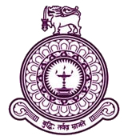

VALUES AND GUIDING PRINCIPLES
- Innovativeness & Exploration
The institute is ready to find new ventures and used this as guiding principles for future development, emphasis on innovations and encourages new ideas as well as thoughts on Ayurveda/Unani.

- Integrity
Institute performing with integrity, its actions, and words always reflect its values and respect each other with equity and equality.

- Continues learning
IIM will always involve in getting to latest technology and used it to disseminate knowledge to undergraduates and society

- Traditional but unique superiorly
IIM courses are blended with unique traditional knowledge with immensely benefited for health sector and the industry. It is motivate factor to introduce new knowledge to heath sector.

- Responsibility and accountability
The institute responsible for its own actions and productions.

- Diversity of subject discipline
The institute always ready to revise and expand the study program to meet the change in environment.

- Commitment & efficiency
The IIM expects its staff's commitments and efficiency in worksto meet challengers and working with highest level of enthusiasm to achieve its goals.

- Owner ship and pride
All academic, administrative, and academic supportive staff will perform as a team and pride to be a member of IIM team.

- Equal Opportunity
The institute recognizes that its strength and unity comes from
providing equal opportunities to everyone, built on the foundations of social justice and equality.

- Futuristic view
Is to meet the needs of the stake holders, IIM will adjust according to the changing social
technological and policy environment.

THE ROLE OF THE INSTITUTE OF INDIGENOUS MEDICINE
The role of the institute is to;
- produce quality Medical Professionals of Ayurveda / Unani who are, equipped with knowledge, skills, attitudes competencies and perform their profession with highest moral and ethical standards as aspired by the public.

- be a self supporting, autonomous body administratively and financially.

- provide indigenous medical education in the relevant fields expected by the state and private sectors.

- taking in to the consideration of the development in the fields of Ayurveda, Unani and traditional medicine contents of the curriculum and reviewed periodically .

- assist the health care services of the country.
- develop research culture to strengthen the Ayurveda Unani medical systems.

- conduct Continues Medical Education (CME) programmes.

- establish collaborative link programmes with other research Institute/ Universities.

- allow staff attend skill development programme.

- to analysis the health requirements of private and public sector

- strengthen a career guidance service for under graduates of the institute to develop their soft skills.

- introduce entrepreneurship development programmes on drug manufacturing which encouraging students for self-employment.

- to improve the Cooperate Social Responsibility (CSR) of the Institute

- entering to the Holistic approach in order to integrate the indigenous medicine with other traditional Medical System.

CORPORATE GOALS

- To Increase Demand to higher Education in Indigenous Medicine
- To Improve Quality of Academic Programmes
- To Strengthen research, Innovation & Entrepreneurship
- To Contribution of the IIM to Socio - Economic Development
- To Increase Interaction with International Institutes
- To Improve Physical & Esthetic Environment Stake Holders Satisfaction of IIM
- To Ensure Financial Management & Sustainability
- To Improve the Quality & capacity of IIM

GOALS& OBJECTIVE OF IIM

Goals | Objectives | Strategy | Action to be taken | Progress
1.To Increase Demand to higher Education in Indigenous Medicine | - Increase enrolment capacity to 240 to 300 by 2023  - Increase demand for postgraduate diploma and certificate courses | - Maintain the quality and potential expansion of content of existing degree programme  - Formation of new degree programme in Para medical field relevant to Indigenous medicine  - Establishment of PGIIM and Center for Open and Distance Learning (CODL) | - Awareness and promotional programme in school  - Orientation programme with parental involvement  - Close relationship with UGC to have full quota of student  - Initiate new programme or subjects discipline at Unit, Departmental, and Institutional level  - Establishment of new distance learning centers on various discipline  - Initiate new postgraduate courses at Unit level  - Initiate new certificate courses in demanded areas  - Review and Revise the existing curriculum and programmes to meet the industrial requirements | Continuing  Continuing  Continuing  Continuing  Continuing  Planning stage  Continuing  Continuing
2.Improve Quality of Academic Programmes | 2.1Improve quality of existing degree programmesto ensure it to be updated to meet national and international requirements  2.2 Increase students  satisfactions  2.3 Enhance the quality of  academic program | 2.1.1 Introduction of new curriculum to meet industrial requirements  - Enhance students academic and other skills (IT, languages , soft skills) to enhance the quality of graduates  2.2.1 Increase quality of teaching,  learning and assessment  methods  2.3.1 Enhance the industry  exposure and provide more opportunity to train in  industry | - Review of curriculum at unit / departmental and degree programme level  - Conducting feedback surveys for stakeholders  - Organize seminars, workshops, study and field visits to get the stake holders views  - Empower market research to get the trends in market industry and employer expectations  - Introduce and enhance the computer literacy to degree programme  - Introduce and enhance the Languages to degree programme  - Organize seminars, workshops to enhance the soft skills of undergraduates  2.2.1.1 Equipped academics with new  materials of teaching , learning  and assessment methods  2.2.1.2 Incorporate students' centered  learning methods to degree  program  2.2.1.3 Introduce and increase IT,  language and soft skills to  curriculum  2.2.1.4 Trained supportive and technical  staff to handle modern equipment  2.2.1.5 Introduce LMS and motivate staff  and students to use it  2.2.1.6 Improve facilities in existing  lecture halls  2.1.2.7 Maintaining the raging free  environment in IIM  2.3.1.1 Increase industrial training  opportunity by having MOU with  relevant organization  2.3.1.2 Establish and strengthen ALUMNI  to increase industrial relations  2.3.1.3 Enhance the carrier development,  counseling and conducting  programs in regular basis  2.3.1.4 Enhance and provide more training  programs to academic staff in  counseling and coaching | Continuing  Continuing  Continuing  Planning stage  Continuing  Continuing  Continuing  Continuing  Continuing  Continuing  Planning stage  Continuing  Continuing  Continuing  Continuing  Planning stage  Continuing  Continuing
3.Strengthen research, Innovation & Entrepreneurship | 3.1 Strengthen research  culture, at IIM  3.2 To enhance the entrepreneurship, IIM knowledge and expertise benefits to the industry and community | 3.1.1 Setup a research fund with  the help of industry and  donors  3.1.2 Improve research  infrastructure  3.1.3 Research collaboration with  local and foreign institutions  3.1.4 Postgraduate courses  3.1.5 Increase knowledge  dissemination methods  3.2.1 Close relation with industry  and community oriented  researchers  3.2.2 To turn research outcomes  to viable goods and services  3.2.3 Research collaboration with  local and foreign instructions | 3.1.1.1 Forma internal team to educate  the stake holders, industry and  donors  3.1.1.2 Departmental level funds to offer  research grant to research,  publication and participation of  conferences  3.1.1.3 Increase IIM contribution to  research and development by10%  annually from capital budget  3.1.1.4 Allocate quota from consultancy  and other services earnings to  research fund of IIM  3.1.1.5 Establishment links with  government , private  organizations and non  government organization to  research and development  opportunities  3.1.2.1 Establish a sectional research unit  3.1.2.2 Update existing facilities, lab,  equipments to facilitate research  culture in IIM  3.1.2.3 Increase E - resources, repeated  journals and data bases to  enhance researchers  3.1.2.4 Increase link with local and foreign  polishers to get subsides rate  3.1.2.5 Establish institutional press and  book shop to disseminate the  research findings  3.1.3.1 Development of directory of expert  in the field of indigenous medicine  3.1.3.2 Increase links and collaboration  with similar institutes and faculties  3.1.3.3 Joint publications of students and  staff  3.1.3.4 Increase participation of students  and staff for the conferences  3.1.3.5 Establish the data base of students'  research projects  3.1.3.6 Annual rewards of excellence to  students and staff  3.1.4.1 Increase postgraduate courses in  different disciplines emphasizing  more research components  3.1.5.1 Organize staff annual research  symposium (national and  international)  3.1.5.2 Start index journal to  disseminated research finding  3.1.5.3 Start a news letter  3.2.1.1 Identify the positional issues,  priorities through enhance link  (workshops, seminars,  conferences)  3.2.1.2 Encourage student research  engagement with industries  3.2.2.1 Organizer institutional (IIM) day  to outcome of research to  industries  3.2.2.2 Enhance media propagation  3.2.2.3 Organize products, launchers,  demonstration to industries and  inviters  3.2.3.1 Appoint a committee to see the  possibility of having links with  foreign investors | Planning stage  Planning stage  Planning stage  Continuing  Continuing  Planning stage  Continuing  Continuing  Continuing  Planning stage  Planning stage  Continuing  Continuing  Continuing  Planning stage  Continuing  Continuing  Continuing  Planning stage  Continuing  Continuing  Planning stage  Planning stage  Continuing  Planning stage  Planning stage
4. Contribution of the IIM to Socio -Economic Development | 4.1 Introduce new pharmaceutical productions  4.2 Promote indigenous  medicine practices  4.3 Encourage cultivation  of medicinal plants | 4.1.1 Increase innovation lead researches  4.2.1 Community development  programe  4.3.1 Selection and  propagation of  quality medicinal plants  4.3.2 Increase the awareness  programme  4.3.3 Empowerment of farmers  to cultivate medicinal  pants | 4.1.1.1 Encourage innovative research  4.1.1.2 Increase the laboratory  4.1.1.3 Established fully fledged Pharmacy  4.1.1.4 Increase the links with  entrepreneurship  4.2.1.1 Organize Medical Camps, mobile  medical clinics, school awareness  programme ,  4.2.1.2 Establish a health care centers  within the premises for community  service  4.2.1.3 exhibitions, international  conferences  4.3.1.1 Encourage the lectures electronic  media and newspapers  publications  4.3.2.1 School and community awareness  programme  4.3.3.1 Establishment of medicinal plants  productions | Planning stage  Continuing  Continuing  Planning stage  Continuing  Continuing  Planning stage  Continuing  Continuing  Planning stage
- Increase Interaction with International Institutes | 5.1 Promote collaborative academic activities with foreign institutes  5.2 To achieve higher ranking  5.3 Popularization of Sri Lankan indigenous systems of medicine globally | - Formulate and implement MOUs with reputed international relevant institutions  5.1.2 Increase opportunity for participation in international conferences/training programs/work shops  5.2.1 Upgrade the existing website to meet the international standard  5.3.1 Disseminations of indigenous medical knowledge | 5.1.1.1 Appointing MOU committee  5.1.1.2 Implementing, monitoring and  Evaluation by internal committee  5.1.2.1 Make aware the importance of participation for international conferences  5.1.2.2 Implement and introduce encouraging programme and allowances  5.2.1.1 Establish a web committee  5.2.1.2 Regular monitoring of websites  5.2.1.3 Establish research links for  increase information base of the IIM  5.3.1.1 Conducting the annual international Conferences  5.3.1.2 Publishing a newsletter and journals | Continuing  Planning stage  Continuing  Planning stage  Continuing  Continuing  Continuing  Continuing  Continuing
6 Improve Physical & Esthetic Environment Stake Holders Satisfaction of IIM | 6.1 Improve facilities for teaching-learning and research  6.2 Increase welfare facilities for staff and students  6.3 Introduce medical insurance scheme with increased benefits | 6.1.1 Improve Research infrastructures  6.2.1 Residential facilities for staff  6.2.2 Establish well equipped gym  6.2.3 Establish welfare shop  6.3.1 Re establish the medical insurance according to the UGC circulars | 6.1.1.1 Establish a sectional research unit  6.1.1.2 Update existing facilities and lab equipment to facilitate research culture  6.1.1.3 Increase e resources , reputed journals and data bases to enhance research  6.1.1.4 Increase links with local and publishers to subsidies rates  6.1.1.5Establish institutional press and bookshop to disseminate research findings  6.2.1.1 Staff Residential facilities  6.2.1.2 Form a committee to do the need  analysis  6.2..2.1 Appoint a committee  6.2.2.2 Establish links to get the funds and equipment  6.2.3.1 Appoint a committee  6.2.3.2 Follow the tender procedure and  select the suitable contractor  6.3.1.1 Select a suitable insurance scheme  6.3.1.2 Get BOM approval | Planning stage  Continuing  Continuing  Planning stage  Planning stage  Planning stage  Planning stage  Planning stage  Planning stage  Planning stage  Future action  Planning stage  Planning stage
7 Ensure Financial Management & Sustainability | 7.1 Fully utilization of capital budget  7.2 Improve the efficiency and effectiveness of finance division  7.3 Strengthen generated funds | 7.1.1 Implementation of proposed project development programs  7.2.1 Adopt nationally accepted  procedures, practices and standards to deliver the financial services to IIM  7.3.1 Formation of postgraduate and external courses  7.3.2 Contribution from donors  and industries | 7.1.1.1 Construct of 8 storied building  7.1.1.2 Construct of boys hostels with multipurpose centers)  7.1.1.3 Construction of gymnasium to support sport facilities  - In-house capacity development program for officers  - Hold Finance Committee and procurement committee regularly  - Adhere to Finance regulations applied to university system  - Adopt Finance regulations  introduced by UGC to all  procurement activities  7.3.1.1 Increase enrolment  7.3.1.2 Modify the course content to meet  wider audience of students  7.3.2.1 Organize donors and well wishers  meeting  7.3.2.2 Investment of funds in profits  generating programs  7.3.2.3 Increase contribution from  consultancy program | Planning stage  Planning stage  Planning stage  Continuing  Continuing  Continuing  Continuing  Continuing  Continuing  Planning  Planning  planning
8. Improve the Quality & capacity of IIM | 8.1 To improve administrative system, process and practices and information delivery through fully operated MIS by 2023  8.2 Development of  master plan | 8.1.1 Establish and implement  MIS covering all operational and administrative function of IIM.  8.1.2 Improve existing  administrative procedures  and practices  8.1.3 Enhance awareness on  administrative/ academic  process, procedures and MIS  8.1.4 Implement/Enhance positive cooperate culture in the institute  8.2.1 Appoint an expert external consultant | 8.1.1.1 Start system investigation, analyze,  Design and implementation of MIS  8.1.2.1 Review the existing process and  categories as required with all  administrative functions  8.1.2.2 Increase training opportunities to  administrators  8.1.2.3 Create opportunities to have  exposures with good  organizations  8.1.2.4 Introduce job rotation  8.1.2.5 To take steps to formulate strategic  management planning unit  (to monitor M/C/A plans)  8.1.3.1 Implement awareness  Programmes on administrative  and academic process,  Procedures to relevant staff  categories  8.1.3.2 Increase awareness programme  on organizational changes to the  community of IIM  8.1.3.3 Introduce and recruit carder with  required skills  8.1.4.1 introduce IIM value system to the  staff of IIM in accordance with the  strategic plan  8.1.4.2 Introduce, inculcate, implement  and adhere values and policy  principles to institute community  8.1.4.3 Organize and encourage collective  cultural , social activities involving  IIM community  8.2.1.1Appoint internal master plan  committee for monitoring  and updating the progress of the  master plan  8.2.1.2 Conduct regular workshop,  Seminars to update master plan in  cooperating changes | Planning stage  Planning stage  Continuing  Planning stage  Continuing  Planning stage  Continuing  Planning stage  Continuing  Planning stage  Continuing  Continuing  Planning stage  Panning stage

KEY PERFORMANCE INDICATORS

GOAL 1: To Increase Demand to higher Education in Indigenous Medicine

No | KPI | Responsibility | Performance Targets
 |  |  | 2019 | 2020 | 2021 | 2022 | 2023
 | Enrollment Capacity Incensement (%) | HOD/Ayu, HOD/Unani AR/SA, | 0% | 0% | 10% | 12% | 15%
 | Introduce new teaching technology uplift the standard of the indigenous medicine | HODs/Ayu, HODs/Unani | 50% | 60% | 70% | 75% | 80%

GOAL 2: To Improve Quality of Academic Programmes

No | KPI | Responsibility | Performance Targets
 |  |  | 2019 | 2020 | 2021 | 2022 | 2023
 | Employability of Graduates | Director, DR,  HODs/Ayu, HODs/Unani  Ministry of Health | 70% | 85%== | 90% | 95% | 100%
 | Activities of QA & Accreditation cell | Director, DR,  HODs/Ayu, HODs/Unani  HeadQA | 50% | 55% | 100% | 100% | 100%
 | Improve the quality & relevance of curriculum | Director, DR,  HODs/Ayu, HODs/Unani | 90% | 100% | 100% | 100% | 100%
 | Use of LMS learning/ Blended learning | Director, DR,  HODs/Ayu, HODs/Unani | 50% | 70% | 80% | 90% | 100%
 | Internship programme | Director, DR,  HODs/Ayu, HODs/Unani  Ministry of Health | 100% | 100% | 100% | 100% | 100%
 | English language skills for undergraduates | Director, DR,  HODs/Ayu, HODs/Unani | 60% | 70% | 100% | 100% | 100%
 | Soft skills training programmes for undergraduate students. | Director, DR,  HODs/Ayu, HODs/Unani | 60% | 70% | 80% | 100% | 100%
 | Introduce certificate courses & postgraduate diploma courses | Director, DR,  HODs/Ayu, HODs/Unani | 6 | 6 | 8 | 10 | 15

9. | Student Centered teaching and learning | Director, DR,  HODs/Ayu, HODs/Unani | 50% | 80% | 90% | 100% | 100%

GOAL 3: Strengthen research, Innovation & Entrepreneurship

No | KPI | Responsibility | Performance Targets
 |  |  | 2019 | 2020 | 2021 | 2022 | 2023
 | Utilization of funds from capital budget for research grants | Director, DR, DB, SAB | 50% | 95% | 100% | 100% | 100%
 | User access to journals in the library | Senior Assistant Librarian | 35% | 50% | 75% | 100% | 100%
 | Publication in index journals | HODs/Ayu, HODs/Unani | 30% | 40% | 45% | 50% | 70%
 | Number of local & international patents | Director, DR,  HODs/Ayu, HODs/Unani
 | Increase public private partnership | Director, DR,  HODs/Ayu, HODs/Unani | 15% | 25% | 35% | 60% | 80%
 | E- library system | Senior Assistant Librarian | 5% | 10% | 15% | 20% | 25%
 | Number of national & international awards | Director, DR,  HODs/Ayu, HODs/Unani | 1 | 3 | 5 | 8 | 12

GOAL 4: Contribution of the IIM to Socio - Economic Development

No | KPI | Responsibility | Performance Targets
 |  |  | 2019 | 2020 | 2021 | 2022 | 2023
 | Research contribution to national development countries | Director, DR,  HODs/Ayu, HODs/Unani | 30% | 50% | 70% | 80% | 90%
 | Application of green technology | Director, DR,  HODs/Ayu, HODs/Unani | 30% | 40% | 80% | 80% | 90%
 | Consultancy provided to economic development of countries | Director, DR,  HODs/Ayu, HODs/Unani | 20% | 30% | 35% | 40% | 50%
 | Course modules for economic development | HODs/Ayu, HODs/Unani | 40% | 50% | 60% | 80% | 100%
 | Social harmony /social event conducting annually | DR, AR, HODs/Ayu, HODs/Unani | 100% | 100% | 100% | 100% | 100%

GOAL 5: Increase Interaction with International Institute

No | KPI | Responsibility | Performance Targets
 |  |  | 2019 | 2020 | 2021 | 2022 | 2023
 | Foreign students enrollment in undergraduate/certificate course/postgraduate diploma | Director, DR,  HODs/Ayu, HODs/Unani | 20% | 25% | 30% | 35% | 40%
 | MOU sign between foreign universities/research institute | Director, DR,  HODs/Ayu, HODs/Unani | 5% | 10% | 15% | 20% | 25%
 | International conference | Director, DR,  HODs/Ayu, HODs/Unani | 100% | 100% | 100% | 100% | 100%
 | World ranking list | Director, DR,  HODs/Ayu, HODs/Unani | 1500 | 1300 | 1100 | 900 | 700
 | Universities in South Asian rank | Director, DR,  HODs/Ayu, HODs/Unani | 30 | 25 | 20 | 15 | 10

GOAL 6: Improve Physical & Esthetic Environment and Stake Holders Satisfaction of IIM

No | KPI | Responsibility | Performance Targets
 |  |  | 2019 | 2020 | 2021 | 2022 | 2023
 | Landscaping for beautification | Director, DR/GA, | 75% | 80% | 90% | 100% | 100%
 | Fully-fledged Gymnasium | Director, DR/GA, | 50% | 80% | 100% | 100% | 100%
 | Playground& pavilion with necessary facilities | Director, DR/GA, | 40% | 60% | 80% | 100% | 100%
 | Health center | Director, DR/GA, | 70% | 80% | 100% | 100% | 100%
 | Improvement of hostel facilities | Director, AR/SA, | 50% | 80% | 100% | 100% | 100%
 | Insurance scheme for academic & non- academic staff | Director, DR, DB, SAB | 0% | 100% | 100% | 100% | 100%
 | Pension scheme for staff members | Director, DR, DB, SAB | 50% | 80% | 100% | 100% | 100%

GOAL 7: Improve Financial Management & Sustainability

No | KPI | Responsibility | Performance Targets
 |  |  | 2019 | 2020 | 2021 | 2022 | 2023
 | Utilization of annual budgetary allocation | Director, DR, DB, SAB | 90% | 95% | 100% | 100% | 100%
 | Financial management information system | Director, DR, DB, SAB | 10% | 50% | 60% | 100% | 100%
 | Cash forecast management system | Director, DR, DB, SAB | 80% | 90% | 100% | 100% | 100%
 | Budgetary &monitoring system | Director, DR, DB, SAB | 100% | 100% | 100% | 100% | 100%
 | Utilization of lecture halls & laboratory | HODs/Ayu, HODs/Unani | 100% | 100% | 100% | 100% | 100%

GOAL 8: Improve the Quality & Capacity of IIM

No | KPI | Responsibility | Performance Targets
 |  |  | 2019 | 2020 | 2021 | 2022 | 2023
 | Implementation of master plan | Director, DR/GA, | 20% | 30% | 50% | 80% | 100%
 | Increase training programmes for administrative staff | DR, AR/Est | 75% | 80% | 85% | 90% | 100%
 | Increase training programmes for academic staff | Director DR, AR/Est | 75% | 80% | 85% | 90% | 100%
 | Increase training programmes for non- academic staff | Director DR, AR/Est | 75% | 80% | 85% | 90% | 100%
 | Providing foreign training for academic staff members | Director, DR, AR/Est | 10% | 20% | 40% | 70% | 100%
 | Providing foreign training for administrative & non- academic staff members | Director, DR, AR/Est | 5% | 10% | 20% | 50% | 80%
 | Introduction of MIS system for the institute | Director, DR, AR/Est | 50% | 100% | 100% | 100% | 100%
 | Manual of Standard Operational Procedures (SOP) | Director, DR | 80% | 100% | 100% | 100% | 100%
 | Teacher student ratio for clinical programme | HODs/Ayu, HODs/Unani | 100% | 100% | 100% | 100% | 100%
 | Vacant cadre position in teaching staff | AR/Est | 2% | 0% | 0% | 0% | 0%
11. | Number of MDs and PhDs | HOD/Ayu, HOD/Unani

OUR CORPORATE STRUCTURE
Organization Chart

The Board of Management of the Institute of Indigenous Medicine

- Prof.PA Paranagama Director ( Chairperson)
- Mr. DT Munasinghe Chief accountant to the ministry of city planning water supply & higher education
- Mr. LH Thilakarathne Additional Secretary(Administrative), Ministry of Health, Nutrition Indigenous Medicine
- Mr. KDCS Kumarathunga Commissioner / Ayurveda
- Dr. RMCK Rathnayake Director-Ayurveda Teaching Hospital
- Dr JCKD Kumarasekara Director- Ayurvedic Research Institute
- Prof. J Perera Dean/Medicine
- Dr.(Mrs.)KC Perera Head / Ayurveda Section
- Dr. BM Najeeb Head /Unani Section
- Dr. C Weerarathne Member of Faculty of Medicine
- Prof. (Ms) SSBDP Soysa Member of Faculty of Medicine
- Prof. P Galappaththi Member of Faculty of Medicine
- Dr. SMH Senabanda Member of Ayurvedic Medical Council
- Mr. C Maliyadda UGC Appointed Member
- Mr. MDD Peiris UGC Appointed Member
- Dr. URPP Wimalasooriya UGC Appointed Member
- Prof. K Senevirathne UGC Appointed Member
- Dr. BM Rishad UGC Appointed Member
- Dr. MDJ Abeygunawardena UGC Appointed Member
- Dr. TP Hendawitharana UGC Appointed Member
- Dr. T Weerarathne UGC Appointed Member
- Mr. WDR Krishantha Director- Department of external recourse of the ministry of finance and mass media
- Mr. T P Liyanarachchi Deputy Bursar -Invitee
- Mr. ML Warnasuriya (AAL) Deputy Registrar - Secretary to the Board

Administrative Staff of the IIM

Deputy Registrar (Examination/ Admin) - Mr. ML Warnasuriya
Assistant Registrar (Establishment) - Ms. HD Dissanayaka
Assistant Registrar (Student Affairs) - Mr. DSRMCP Gunawardhana
Deputy Bursar (Accounts) - Mr. TP Liyanaarachchi (Sabbatical Leave)
Senior Assistant Bursar (Payment) - Mr. HMG Punchibanda
Senior Assistant Bursar (Supply) - Mr. PHU Nishshanka

Senior Assistant Librarians - Dr (Mrs.) CK Gamage
- Mrs. PM Ayomi

Medical Officer - Dr. (Mrs) LDR DeSilva

Student Counselors

Senior Student Counselor - Dr. SP Molligoda

Student Counselor/Ayurveda - Dr. SKMK Harapathdeniya
- Dr. APA Jayasiri
- Dr. KWK Somarathna
- Dr. LDR DeSilva

Student Counselor/Unani - Dr.BM Nageeb
- Dr. AHM Mawjood
-Dr. MI Manuha
-Dr. MHM Nazeem
-Dr H Nizamdeen
-Dr. MAA Sirajudeen

Head / Information Technology -Dr. Anoma Samarawickrama

Hostel Administrators

Hostel Warden /Girls - Dr. (Mrs.) SKMK Harapathdeniya
Sub-Warden/Girls - Mrs. DMCK Dissanayake
Hostel Warden/Boys - Dr. NDN Jayawardana
Sub-Warden/Boys (Acting) - Mr. WK Senevirathne

The Heads of Departments of Study

Department of Study in Ayurveda
Head / Ayurveda Section - Dr. (Mrs.) KC Perera
Academic unit of Moulika Siddhantha - Dr (Mrs.) SPA Molligoda
Academic units of Allied Sciences - Dr (Mrs.) MRM Wikramasinghe
Academic unit of Dravyaguna Vignana - Dr (Mrs.) APA Jayasiri
Academic unit of Swasthavritta - Dr (Mrs.) YSG Wimalasiri
Academic unit of Kaya Chikitsa - Dr NDN Jayawardhana
Academic unit of Shalya Shalakya - Dr (Mrs.) LDR De Silva
Academic unit of Prasuthi Thantra Kaumarabhritya -Dr (Mrs.) WASS Weerakoon
Academic unit of DesheeyaChikitsa - Dr SMS Samarakoon

Department of Study in Unani

Head /Unani Section - Dr.BM Najeeb
Academic unit of Kulliyath - Dr (Mrs.) AM Muthalib
Academic unit of Allied Sciences - DrALM Ihsan (Head of the Academic Programme)
Academic unit of Ilmul Advia - Dr MSM Nasmeer
Academic unit of TST - Dr MHM .Hafeel
Academic unit of Moalijat - Dr MHM Nazeem
Academic unit of Ilmul Jarahat - Dr (Mrs.) AHA Fazeenah
Academic unit of Niswanva Quabalat - Dr (Mrs.) H Nizamdeen
Academic unit of Desheeya Ilaj - Dr MAA Sirajudeen

The Academic Staff of the Departments
Department of Study in Ayurveda
* There are eight Units of Study in the Department of Ayurveda

Academic Unit of Moulika Siddhantha

Dr. RS Jayawardhana BAMS, MD (Ay), PhD | Senior Lecturer Gr I
Dr. (Mrs.) IGPRKulanathaBAMS, MD (Ay) | Senior Lecturer Gr I
Dr. (Mrs.) SP MolligodaBAMS, M Phil, MD (Ay) | Senior Lecturer Gr I&Head
Dr.(Ms)MWSJ Kumari BAMS, MD (Ayu), PhD | Senior Lecturer Gr II
Dr. Asoka Gunasekara BAMA, M Phil, PhD | Senior Lecturer Gr II
Dr. PK Wendabona BAMA, M Phil, PhD | Senior Lecturer Gr II
Dr. (Mrs.) PASN Silva BAMS, BA, MA | Lecturer Probationary

Academic Unit of Allied Sciences

Dr.(Mrs)PR Waratenne BAMS, MD (Ay), PhD | Senior Lecturer Gr I
Dr. (Mrs)MRM Wikramasinghe BAMS, MD (Ay)  Dr.ALM IhsanBUMS , MD (Unani) | Senior Lecturer Gr II & Head  Lecturer &Head of the Academic Programme/Unani
Dr. DAL Munasinghe BSc, MSc,PhD | Lecturer
Dr. (Mrs) S Weerasekara BAMS | Lecturer
Dr.(Mrs)BSMM SooriyaarachchiBAMS | Lecturer

Academic Unit of Dravyaguna Vignana

Dr.(Mrs.)SD Hapuarachchi BAMS,MD(Ay),MSc, PhD | Senior Lecturer Gr I
Dr.(Mrs.) SKMK Herapathdeniya BAMS,MD(Ay) | Senior Lecturer Gr II
Dr.(Mrs.) APA Jayasiri BAMS, M Phil (Ayu), PhD | Senior Lecturer Gr II & Head
Dr. PK Perera BAMS, MSc, PhD | Senior Lecturer Gr II
Dr.(Mrs.)JM Dahanayaka BAMS, M Phil (Ayu) | Senior Lecturer Gr II
Dr.(Mrs.) ND Kodithuwakku BAMS,MSc,PhD | Senior Lecturer Gr II
Dr. (Mrs.) MS Pallie BAMS, MSc | Lecturer Probationary
Dr. (Mrs.) KNA Dharmasena BAMS | Lecturer Probationary
Academic Unit of Swasthavritta

Dr.(Mrs.) KC Perera BAMS, MD (Ay) | Senior Lecturer Gr I
Dr.(Mrs.) WMSSK Kulathunga BAMS,MD (Ay) | Senior Lecturer Gr I
Dr. TDN KarunaratneBAMS, MPhil (Ayu) | Senior Lecturer Gr I
Dr.(Mrs.)YSG Wimalasiri BAMS, PhD | Senior Lecturer Gr II &Head
Dr.(Mrs.)WKBDS FernandoBAMS | Lecturer Probationary
Dr. (Mrs.) PANG Perera BAMS, MSc | Lecturer Unconfirmed

Academic Unit of Kaya Chikitsa

Prof.(Mrs.)ERHSS Ediriweera BAMS, MD (Ay),PhD |  | Professor
Dr.(Mrs.) NVP Rohini BAMS, M Phil (Ayu) |  | Senior Lecturer Gr I
Dr.(Mrs.) RDH Kulathunga BAMS, MD (Ay), PhD |  | Senior Lecturer Gr II
Dr.(Mrs) KR WeerasekaraBAMS, M Phil (Ayu),PhD |  | Senior Lecturer Gr II
Dr.(Mrs) HGSP HewageeganaBAMS, M Phil (Ayu), PhD |  | Senior Lecturer Gr II
Dr.(Mrs) EDTP GunaratnaBAMS,M Phil (Ayu), MD (Ay) |  | Senior Lecturer Gr II
Dr.KIWK SomarathnaBAMS, MD (Ayu) |  | Senior Lecturer Gr II
Dr.(Mrs)RHSK DeSilva BAMS, MD(Ay) |  | Senior Lecturer Gr II
Dr.NDN Jayawardhana BAMS, MD (Ay) | Senior Lecturer Gr II&Head
Academic Unit of Prasuthi Thantra Kaumarabhritya

Prof APG Amarasinghe BAMS, MD (Ay), PhD | Senior Professor
Dr.(Mrs) SAD Siriwardhana BAMS, MD (Ay), PhD | Senior Lecturer Gr I
Dr.(Mrs) KPKR Karunagoda BAMS,MS (Ayu) | Senior Lecturer Gr I
Dr.(Mrs) WASS WeerakoonBAMS,MPhil(Ayu), PhD | Senior Lecturer Gr II &Head
Dr.(Mrs) IAM Leena BAMS, MD (Ay) | Senior Lecturer Gr II
Dr.(Mrs)YAUD KarunaratneBAMS, MS (Ayu) | Senior Lecturer Gr II
Dr.(Mrs) OTMRKSB Kalawana BAMS, MD (Ayu) | Senior Lecturer Gr II

Academic Unit of Shalya Shalakya

Dr. LPA Karunathilake BAMS, MS (Ay), PhD | Senior Lecturer Gr I
Dr. SV Kamal BAMS, MS (Ay) | Senior Lecturer Gr I
Dr.(Mrs) DAR Sakunthala BAMS, MS (Ay) | Senior Lecturer Gr I
Dr DPA Dissanayaka BAMS, M Phil (Ayu) | Senior Lecturer Gr II
Dr.(Mrs) LDR DeSilva BAMS, MD (Ayu) | Senior Lecturer Gr II&Head
Dr.(Mrs)BMS Amarajeewa BAMS, MSc, MS (Ay) | Senior Lecturer Gr II
Dr.(Mrs) KKVS Peshala BAMS, MS (Ay) | Lecturer Unconfirmed

Academic Unit of Desheeya Chikitsa

Dr. SMS Samarakoon BAMS,MD(Ay), PhD | Senior Lecturer Gr I &Head
Dr.(Mrs.)AG SamarawikramaBAMS,MPhil(Ayu),MD (Ay) | Senior Lecturer Gr II
Dr.(Mrs.)RLDS Ranasinghe BAMS,MD (Ayu) | Lecturer Probationary

Department of Study in Unani
*There are eight Units of Study in the Department of Unani.

Academic Unit of Kulliyath

Dr. MCM Mahees BUMS, MD (Unani) | Senior Lecturer Gr I
Dr(Mrs.) MI Manuha BUMS, M Phil (Unani), PhD | Senior Lecturer Gr I
Dr. (Mrs.) AM Muthalib BUMS, PhD | Lecturer & Head
Dr. ALM IhsanBUMS, MD (Unani) | Lecturer
Dr. AR Hasmath BA | Lecturer

Academic Unit of Allied Sciences

Dr.ALM Ihsan BUMS , MD (Unani) | Lecturer &Head of the Academic Programme/Unani
Dr. (Mrs)MRM Wikramasinghe BAMS, MD (Ay) Senior Lecturer Gr II & Head
Dr. J Rumaiza BUMS, MS (Unani) Senior Lecturer Gr II
Dr.(Mrs.) AFM Joonoos Lecturer Probationary

Academic Unit of Ilmul Advia

Dr. BM Nageeb BUMS, M Phil (Unani), PhD | Senior Lecturer Gr I
Dr. AHM Mawjood BUMS, M Pharm, PhD | Senior Lecturer Gr I
Dr. MMM Rifaee BUMS, M Phil (Unani) | Senior Lecturer Gr II
Dr.(Mrs)N Fahamiya BUMS, MD (Unani) | Senior Lecturer Gr II
Dr.M Nasmeer BUMS, MD (Unani) | Senior Lecturer GrII& Head
Academic Unit of Tahaffuziwa Samaji Tib

Dr.(Mrs)MSS Fawmiya BUMS, MPhil (Unani) | Senior Lecturer Gr II
Dr. MHM Hafeel BUMS, M Phil, MD (Unani) | Senior Lecturer Gr II &Head
Dr.(Mrs)M.N.F.RizwanaBUMS,MD(Unani) | Lecturer

Academic Unit of Moalijat

Dr(Mrs.) AWS Fowziya DAMS, M. Phil. (Unani) | Senior Lecturer Gr I
Dr (Mrs.) MLU SalmaBUMS, MD (Unani) | Senior Lecturer Gr I
Dr. MHM Nazeem BUMS, M Phil (Unani) | Senior Lecturer Gr II & Head
Dr. SM Raeesuddeen BUMS, MD(Unani) | Senior Lecturer Gr II
Dr MSM Shiffa BUMS, MD (Unani) | Senior Lecturer Gr II
Dr (Mrs.) AM Muthalib BUMS, PhD | Senior Lecturer Gr II
Dr. MAA Sirajudeen BUMS, M Phil (Unani) | Lecturer
Dr(Mrs.)MCN Razana BUMS, MD (Unani) | Lecturer

Academic Unit of Ilmul Jarahat

Dr.(Mrs.) AHA Fazeenah BUMS,MD (Unani) | Senior Lecturer Gr II & Head
Dr. (Mrs.) AFM Joonus BUMS | Lecturer Probationary

Academic Unit of Amraz e Niswan, Qabalat Va Atfal

Dr.(Mrs.)H Nizamdeen BUMS,MD (Unani) | Senior Lecturer Gr II & Head
Dr.MH Faslul Haq BUMS, MPhil (Unani) | Senior Lecturer Gr II
Dr.(Mrs.)MUZN FarzanaBUMS, MS (Unani) | Senior Lecturer Gr II
Dr.(Mrs.) J Rumaiza BUMS, MS (Unani) | Senior Lecturer Gr II

Academic Unit of Desheeya Ilaj

Dr. MAA Sirajudeen BUMS, MPhil (Unani) | Lecturer& Head
Dr.(Mrs.) FN Jamaldeen BUMS | Lecturer

Dr.M Nasmeer BUMS, MD (Unani) | Senior Lecturer Gr II&

