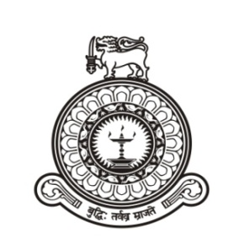

Institute of Indigenous Medicine
University of Colombo

Vacancies

Applications are invited for the following posts at the Institute of Indigenous Medicine, University of Colombo.
- Senior Lecturer Grade I/ Senior Lecturer Grade II/ Lecturer (Unconfirmed) Lecturer (Probationary) in Western Medicine (MBBS)
Fields: Anatomy, Physiology, Pathology, Forensic Medicine, Clinical Medicine
- Senior Lecturer Grade I/ Senior Lecturer Grade II/ Lecturer (Unconfirmed) Lecturer (Probationary) in Ayurveda Medicine (BAMS)
Fields: Ayurveda Sharira Rachana, Ayurveda Sharira Kriya
Salary Scale (as at 01.01.2020):
- Senior Lecturer Grade I Rs. 91310-7x2170-106500 p.m.
- Senior Lecturer Grade II Rs. 79360-11x1630-97290 p.m.
- Lecturer (unconfirmed) Rs. 69580-5x1630-77730 p.m.
- Lecturer (Probationary) Rs.54600-10x1335-67950 p.m.

In addition to the salary, academic allowances approved by the University Grants Commission will also be paid.
Other Benefits:
- Senior Lecturer Grade I/ Grade II will be entitled for sabbatical leave of one year duration with full pay, on completion of seven years of service.
- Gratuity payment at the retirement/ end of the service, in accordance with the provisions of the payment of gratuity Act No. 12 of 1983.
- Contributions by the employer, to the University Provident Fund and the Pensions of the employee in 7% and 8% of the salary by the employee, respectively.
- Employees Trust Fund benefits of 3% of the salary, by the employer.
How to Apply: Further particulars and application forms can be obtained from the Assistant Registrar/ Establishments Branch of the Institute during office hours, by sending a request accompanying a self-addressed stamped envelope of 23x10 cm in size. Application forms can be downloaded and other particulars can be viewed through the Institute web site: www.iim.cmb.ac.lk
All applications should be forwarded to the Assistant Registrar/ Establishments, Institute of Indigenouis Medicine, Rajagiriya under registered cover to reach on or before 07.11.2018.
Application without attached copies of certificates, incomplete and late applications will be rejected without intimation.
Employees in Public Service, Corporations and Statutory Boards should forward their applications through the respective Heads of the Departments.

Director
Institute of Indigenous Medicine
Rajagiriya.
08.10.2018

