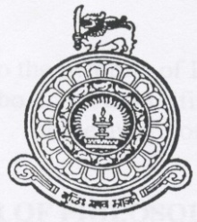
INSTITUTE OF INDIGENOUS MEDICINE
UNIVERSITY OF COLOMBO
Certificate Course in
MASSAGE THERAPY - 2018
Application will be accepted for the above programme on or before 15th of January
Admission Requirements
Candidate should have one of the following qualifications
- G.C.E. Ordinary Level Examination with 2 passes for Language and Mathematics, not exceeding in 2 times/equal qualification for foreign candidates
and
2. 2 year experience in the relevant field

The candidates who meet eligibility requirements and who are successful at the interview will be selected to the program.
Duration of study : Four months ( Weekend)
Course Fee : Rs. 30,000/= (nett)
Application fee : Rs. 1000/=
Medium of Instruction and Evaluation : Sinhala / English
This course is designed to commence on February 2018. Application forms and other information can be obtained from course coordinator or institute web site: http://iim.cmb.ac.lk
Application fee should be paid to the bank.

Name of the Bank : Peoples Bank -Borella
Account number : 078100192268358
Duly filled application forms attached with the bank receipt should be handed over or send by post on or before 31stof January 2018 to following address.
Contact
Head of the Department
Department of Swasthavritta
Institute of Indigenous Medicine
University of Colombo,Rajagiriya.

Phone:
0094112694308 Ext 204 `

